Soylent Ghoul
Ghouls are real. Vampires, wendigo, all manner of depraved abominations have existed in the shadows the world over throughout time. Men who feast on the flesh of other men change, they gain terrible powers and dark urges. Most die, their bodies ripped asunder from the inside out, but a few have always survived. This was scarcely a problem, a tiny handful of beings each generation, dotted around the globe, isolated and alone, hiding in shadows, humanity could easily sustain such a parasite.
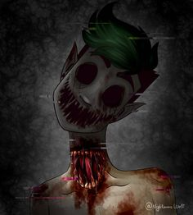
Then the Soylent Green crisis came. A solution to the worldwide food shortage, a worldwide solution, backed by governments across the planet. Soylent Green contaminated the food chain on every level, the tiny percentage of humans not changed were soon torn to shreds. We’re all ghouls now.
Those with the will to power dominated and transformed others into their image. Ghouls, it transpires, can feed on other ghouls, and that’s all the world is now. The odd flickering light in the darkness that always marks nothing more than one group feeding on another. This then is how the world ends, not with a bang, or a whimper, but a long, broken, red and shatter toothed scream.

Gameplay Essentials.
Players will need an equal number of drones each, being miniatures on square bases, 4 is a good number. For each drone they should have five tokens, blank on one side, on the other marked to indicate their drone and with one marked as “true”. They will also need a few d8s and a good handful of other tokens. Play on a 2’ square surface and put out whatever terrain you wish, but plenty of sight line blocking walls and buildings are a good idea.
Terrain.
Players should agree to the height of each piece of terrain during set-up as a round number with the main playing surface being 0.
Table edge.
Off the playing area is considered “fatal”, any drone moved there is removed from the game, players may designate any other areas they wish to be “fatal” at set-up.
Vision arcs.
Each miniature has a front, two sides and a rear, defined by the front of the model facing one edge of the base. The 90-degree arc formed by drawing a line through two diagonally opposite base corners are “Clear” in front of the model, “Peripheral” to its sides and “Blind” in is rear.
Sight.
When checking to see if a drone in Soylent Ghoul can see a target, trace a straight line between them:
- A drone cannot see the target if the line crosses any terrain with a height greater than the height of the terrain the drone is currently stood on.
- A drone cannot see the target if the line passes outside of the drone’s clear arc at any time.
If any line can be traced that does not fit either of those two conditions, the drone can see the target at the other end of the line.
Panic.
Drones will gain panic tokens; these are any convenient token placed next to the drone. Drone tokens.
Drones and Tokens.
Each Drone is deployed with a set of tokens, some of these tokens represent shadows and sounds, one of them represents the drone themselves. Using tokens to cause an opponent to panic is a vital part of Soylent Ghoul. If a token is removed for any reason, all panic tokens on it are moved to another token attached to the same Drone of the controlling player’s choice. A player may replace the true token of a set with its Drone at any time, in which case, remove all other tokens attached to that drone. In the following rules, “Character” designates rules that are true for both Tokens and Drones. If the true token of a set is removed or revealed, remove all other tokens of the set.
Gameplay.
Players take turns passing left around the table, most morally suspect player goes first.
Player Turn.
Players either place or activate a Character.
To place: If a Drone has not been placed yet this game take its five tokens and stack them anywhere on the table the player wishes.
To activate: The player selects one of their Characters and moves it according to the rules below. If a Character is activated by the same player twice in a row, it gains a panic token.
Move.
To move trace a line touching a surface at all times no longer than the Character’s M in inches that ends on a horizontal surface at least the size of the Character’s base, place the Character there.
Panic.
Once a move is made, starting with the player controlling the moved Character players take turns selecting a single Character and placing 1 panic token on them to either spin them on the spot up to a facing of their choice or move them 6” directly forwards, stopping if they contact terrain with a height greater than the height of the terrain they are currently on.
Whenever a Character receives a panic token roll a D8 and add the number of tokens already on it (before the addition of the current token). If the result is over the Character’s nerve rating its “Snapped” effect takes place. Drones may no longer move or take actions and will have a group specific effect. Tokens that Snap are removed immediately.
Continue until no player wants to place panic tokens.
Action.
If the Character has any actions it may perform exactly one of them now, then the next player takes their turn. Last player with at least one un-Snapped drone wins.
The power of the gaze.
If a Drone has clear line of sight to a token reveal it, if it is a true token replace it with its Drone, if not, remove it.
Ghoul Groups.
Scene Shifters-
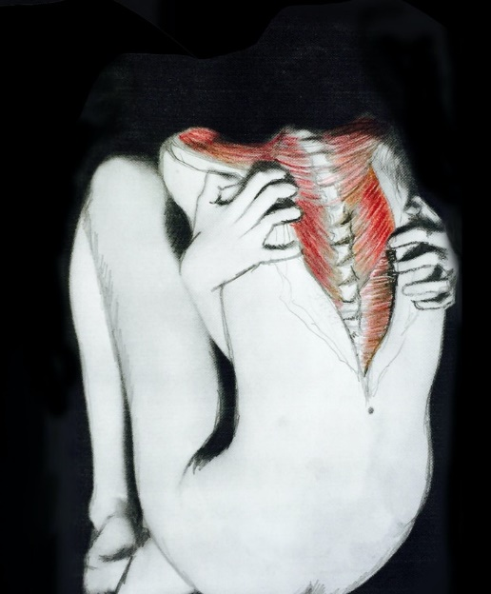
Artists painting across reality, the scene shifters transcribe visions of depravity and horror across the fabric of vision itself. To become enfolded within the turns of their twisted art is to allow their visions into the waking world and dance with a madness that wears your skin like an ill-fitting shawl. Obsessed with their deadly works every scene shifter suffers under the burden of never being able to witness their own genius until inevitably they all give in to the temptation of their own brilliance, falling shivering and gibbering with an ear-splitting smile at the transcendence of their oh so unique darkness.
M=3 Nerve=7
Actions
Scene – A Character may place a marker identifiable as belonging to its Drone.
Shift – A Drone may select any number of markers placed by Scene Shifters and draw straight lines between all of them. Any Character in a section described by those lines gains 5 panic tokens. Characters gain 2 panic tokens for every marker belonging to its Drone not selected. The Drone that takes this action suffers 2 panic for every marker used in the action that does not belong to it.
Snapped – Remove the Drone’s markers, if its True token is in play, replace it with the Drone, counts as a marker for all other Scene Shifters that must be used during any Shift actions.
Eyes-
Figures in the darkness, flickers in mirrors, on the edge of sight, the eyes want to see you, see in you, see through you. Until they find what it looks like to see your face from your own bleeding eye sockets. Then they’ll want to see more.
M=12 Nerve=3
Actions
Check – A Drone may draw Clear line of sight from to every Drone that cannot draw Clear line of sight to it in return. The target Drones gain 1 panic token plus 1 for each other Eye Character that can draw a Clear line of sight to them. This Drone suffers 1 panic token for each Eye Character that can draw a Clear line of sight to them that they can only draw a Blind line of sight to.
Snapped – Enemy Characters can use this Drone’s line of sight as their own.
Mannikins–
Whispering and giggling with limbs that whitter and click like the chitin plates of an insect. Desiccated in body and soul, throat cartilage flapping, open to the wind. They just want to get close to you, closer and closer and closer, holding you as you die into them.
M=24 Nerve=6
Actions
Become – If this Drone is in target Character’s blind zone, target suffers 4 panic -1 for every 3” away they are. For each enemy Character that can draw a clear line of sight to this drone this drone suffers 1 panic.
Snapped – Enemy Characters can use this Drone’s line of sight as their own.
Gardeners-
The dead lie not easy and hands flow below the surface of the ground, seeking, groping and reaching. The shuttered lanterns of the Gardeners attract these questing hands like blind lilywhite moths. The light keeps them at bay, but just at the edge of the flickering lamplight. The gardeners shutter their lights to drop those around them into darkness and the hands pull them down, pushing fingers through flesh like butter, seeking marrow and offal. But the lanterns are old and unreliable, each gardener flirts with their own destruction, being pulled deeper below with every dip of the wick or flutter of the light. Those with just their toes beneath the loam have learnt of the path they have begun down, those knee-deep or worse weep for their future, seeking enough of the flesh of others to find a few moments of peace.
M=3 Nerve=6
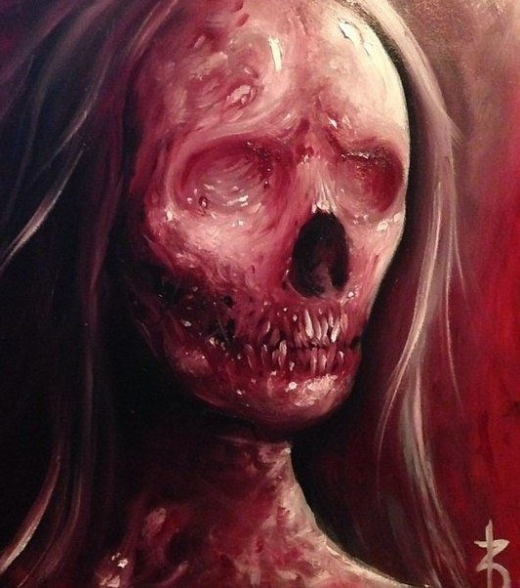
Actions
Lighter – This Character sets a light level from 1-7, all Characters within the number in inches from this drone (including this drone) gains a light token.
Darker – Reduce this drone’s lantern number by any amount, roll a D8, if it is equal to or under the amount of the reduction remove this drone’s lantern number. All Characters with light tokens that are not within the light level in inches of a gardener or able to trace clear line of sight to a Gardener Drone other than themselves gain 5 panic tokens.
Snapped – All Gardener drones take the Darker action reducing their lantern number by 6.

