Version 3.0 08/02/22

Survivor

Overview:
Survivor is a tabletop skirmish game of ongoing survival horror. It will tell the story of a group of individuals coming together and struggling to make it through, and that of many other groups failing. It focusses on the relationships between survivors, their stories and connections. Combat will be brutal, deadly and best avoided, scarce resources and punishing environments are the deadliest opponent to face. Only by the swift gathering and careful management of resources and crafting of tools will a dog’s chance at making it through be possible. Survivor should be played in a series of sessions. To play Survivor players will need to select from one of a range of challenging environments, build a group of people to try and keep alive, and then play out their story to rescue or destruction. This the tale after the movie is over, the forever story of survival.
Contents
What You Need To Play: 3
Core Concepts: 3
Days: 3
Exposure: 3
Exhaustion: 3
Desperation: 3
Relationships: 3
Incapacitated: 4
Ranges, Distances and Measuring: 4
How To Play: 5
Setting Up Camps: 5
Generating groups: 5
Recording Connections: 5
Leadership: 6
Foraging: 7
Scouting a location: 7
Choosing a team: 8
Discover the location: 8
In The Field: 9
Movement: 9
Line Of Sight: 9
Exposure: 9
Combat: 9
Searching: 9
Controlling Creatures: 9
Predators: 9
Prey: 9
Returning to Camp: 9
Maintaining Camp: 9
Crafting: 9
Activity: 10
Consumables: 10
Tools: 10
Structures: 10
Starvation: 10
Revolt: 11
Desertion: 11
Environments: 11
General/Modular: 11
Wet/Dry: 11
Hot/Cold: 11
Teeming/Deserted: 11
Fecund/Barren: 11
Raft: 11
Desert: 11
Jungle: 11
Arctic: 11
Challenges: 11
Ending the Story: 11
Factions: 11
Officer Led: Cult of Personality: Dispossessed: Going Native: 11
Bestiary: 11
Armoury: 12

What You Need To Play:
Each player will need a Relationship Sheet to track their group members’ connections, a Camp Sheet to track their resources, team members and constructions and a Foraging Sheet for each Foraging session to track the status of Characters and chart progress out in the wilds. They will need a handful of miniatures representing their survivor.
The group will need a 3’ by 3’ space to play on with a collection of scenery, terrain and creatures defined by their chosen environmental Zone (see page XX) and a single shared Wilderness Map. There will be caches of supplies either naturally occurring or within dumped crates, these should be noted with either a set of counters or suitable models identifiably numbered from 1-6. The group will need 6 six-sided dice, whenever these rules refer to a die or dice, they mean a standard six-sided dice numbered from 1 to 6, which may be referred to as a D6.

Core Concepts:

Live and Recorded play:
A game of Survivor consists of sessions of both Live and Recorded play. Live play is that which requires the other players involved in the game to be present and will consist of a tabletop skirmish represented by a set of miniatures manipulated by tape measures and six-sided dice. Recorded play is that which can, and usually should, take place with each player in isolation. Recorded play consists of a series of, sometimes complex and considered, choices in relation to building camp and crafting objects. Recorded play requires no randomization or interaction with other players, allowing it to take place in solo play conditions. At the start of each Live play session following a Recorded play session it is good practice for players to make a quick explanation of actions taken during Recorded play.

Days:
One of the main costs of actions outside of tabletop play sessions in Survivor is days, various activities in Camp and around take days to complete, and as days pass resources must be consumed.

Distance, Direction and Time:
Between Foraging sessions different players may take different numbers of days and yet they will arrive at the next Foraging at the same time. In addition, they may at times set off from different points and yet arrive at the same location. This is fine, far from normal civilization time can be hard to measure and in the wilderness with no understandable landmarks directions impossible to maintain.

Table Edges:
The edges of the designated play area are the “Table Edges”. Any Character or creature that moves to contact a table edge is immediately removed from play.

Exposure:
The environments in Survivor are varied, but all are potentially deadly. Characters will accumulate Exposure the longer they spend in these environments, which will remain unless removed by player actions or by consuming resources.
If a Character accumulates 20 or more Exposure, they lose a limb.
If a Character accumulates 40 or more Exposure, they become incapacitated.
If a Character accumulates 60 or more Exposure, they suffer a wound.

Loss of Limb:
If a Character loses a limb, they reduce a stat of their choice by one. At the start of each Foraging they roll a D6, on a 1 they suffer one poison.

Incapacitated:
Characters may become so severely injured that they are little more than a burden to the Camp. Their continued survival is a paean to our collective humanity.
An incapacitated Character cannot be selected to go on a Forage or assigned to Crafting. They still consume food and may desert.

Death:
If a Character or creature suffers as many or more wounds as its wounds stat it dies (or is killed). This may occur in camp or during a foraging, if a Character is killed remove them and all connections to them. Any character with a connection to the removed character removes a line of connection between them and the current leader. If a creature is killed it becomes Carrion, a possible source of resources (see page XX)

Exhaustion:
When characters push themselves in extreme situations they will suffer exhaustion, which will remain until they take some sort of respite.
If a Character activates with 6 or more Exhaustion, they may not take any actions that increase Exhaustion during the activation.

Desperation:
Whether in desert or tundra, all the characters in Survivor know very well that they have little or no chance of making it back to their home and loved ones. The relentless mental pressure can eventually break them, driving them to leave camp, either to seek another group, strike out on their own, or just find the space to end it all with dignity.
If a character ever has 10 or more desperation, they desert.

Poison:
If a Character ever has 5 or more poison they suffer 1 wound.

Relationships:
Characters in Survivor have levels of relationships showing the bonds of blood forged in extreme situations, these relationships will boost their capabilities when running to the aid of a friend or if supported by blood brothers. These relationships will be represented on the Camp Sheet by a series of lines connecting Characters together.

Ranges, Distances and Measuring:
Survivor uses inches as a unit of distance, to use centimeters simply double all measurements. Miniatures representing characters should be of 28mm scale, which is to say, roughly 28mm from foot to eye level. Miniatures of Mass 1 should be on bases of 30mm across or less, those of Mass 2 should be on bases 30mm to 50mm across. Measurements can be taken from or to any convenient part of a miniature or its base, so long as when measuring movement measurements are taken from consistent points on the same miniature.

Impermanent alterations:
The game will ask for elements to be both recorded and changed on the various sheets and maps. Players should assume that anything so recorded is subject to change and use erasable means such as a pencil to record them.

How To Play:
At the start of the first Live play session of Survivor for a group there needs to be a collective period of generating each player’s starting camp. From that point onwards a session of Survivor consists of a part using a tabletop miniatures skirmish game to represent Foraging for supplies, which needs to be conducted with all players together, and a part in Camp dealing with the results of foraging, which may be conducted in isolation.

Setting Up Camps:

Locate the Camp:
At the start of the first Live play session players should collectively select a zone representing the environment the Characters find themselves stranded in. This can either be one of the pre-set zones or one constructed using the modular zone system (page XX). Record the zone type or elements at the top of the group’s Wilderness Map, record the starting Camp location in the highlighted central hex.

Generating groups:
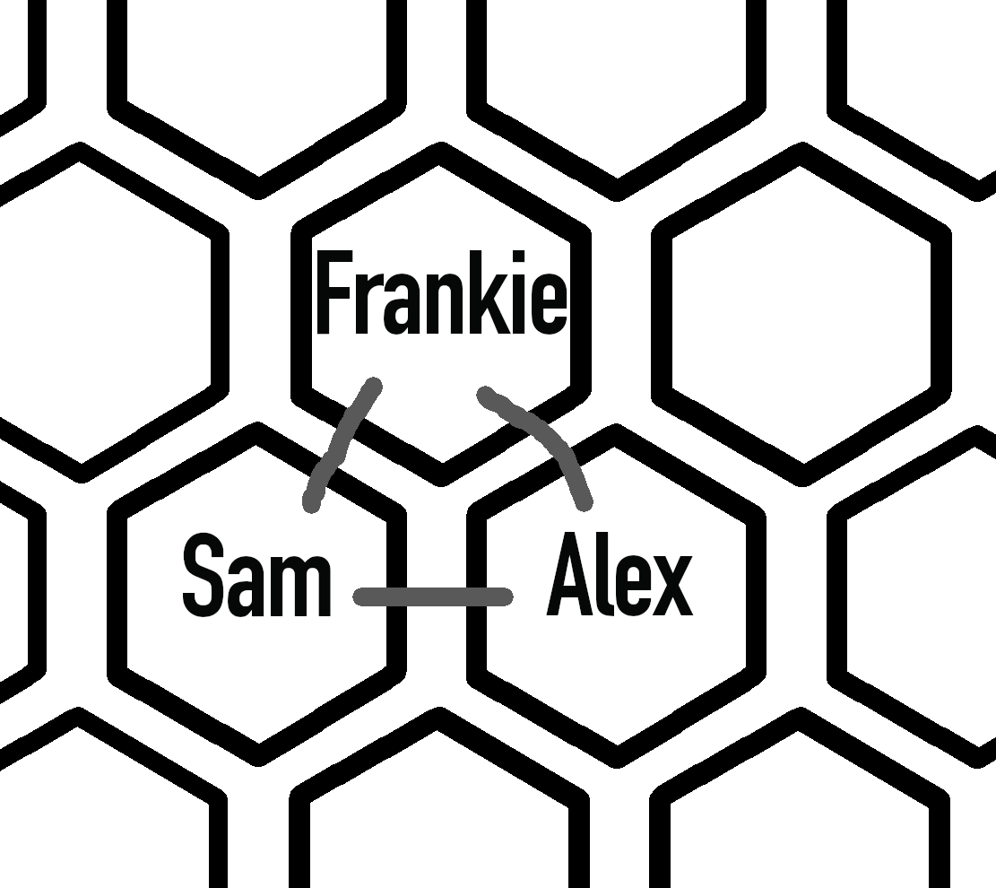
Each player controls a Camp consisting of a group of characters. Following recording of the Camp location on the Wilderness Map players will need to generate their group. Each player starts with 9 bidding resources. Roll a dice, halve the result and round up to generate a number from 1 to 3 to decide how many Characters are in each approaching group. Players take turns to bid resources, a group of 1 Characters has a minimum bid of 1, 2 a minimum bid of 3 and 3 a minimum bid of 6. If no players have 6 resources divide the result of the dice by 3, if no players have 3 resources all groups will consist of a single Character. Start bidding with a randomly determined player on the first group and pass left, then pass first bid right on following groups. Players are permitted to bid zero, players must either raise the previous bid or bid zero. Groups that all players bid zero on are removed, if only one player has resources remaining and they can afford to bid on a group they must bid. If only one player has a non-zero bid, they claim the group. Failed bids are returned to the loser, successful ones are lost.
Once a group is claimed by a player, they are added to their Relationship Sheet and each individual is recorded on their Character Sheet. Members of arriving groups should be recorded in adjacent spaces on the sheet and all have Colleague connections to each other member of that group.

Recording Connections:
Whenever a Character joins a Camp, they should be added to the Relationship Sheet by their controlling player picking a name for them and recording that name in the hex of their choice, if they arrived as a group, the hex must be adjacent to at least one other member of that group.
Events may strengthen or break down relationships between Characters, represented by a series of lines connecting them together. Whenever a player is requested to upgrade or downgrade the connection between two Characters, they should draw or erase the lines between them to match those on the Relationship sheet. These alterations should be made on the sheet as soon as the connections are made or lost. If a connection would cross another connection or character, it cannot be made. It should be noted that the first drop down in level of connection involves making the single line into a dotted line (do so by erasing parts of the line), this is still a single line and cannot cross other lines or characters.
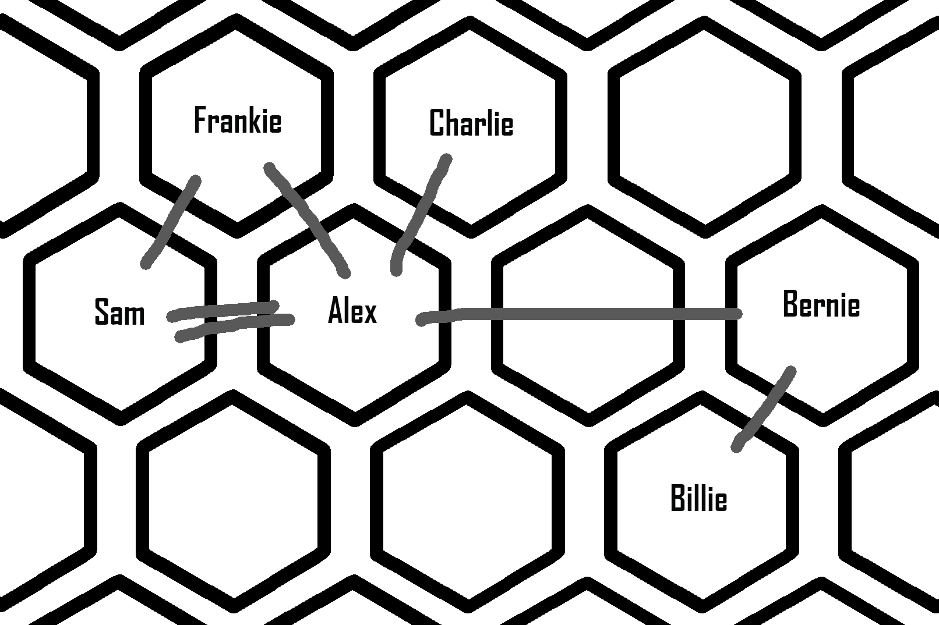
A Character has as many Connection Points as there are lines leading to them, and two Characters have a Shared Connection level equal to the number of lines there are directly between them.
Alex has five Connection Points, a Shared Connection of two with Sam and one with Frankie, Charlie and Bernie. Charlie and Billie cannot have a connection made between them.

Leadership:
The Camp’s Leader is the Character with the most Connection Points, if there is a tie the controlling player chooses between Characters. During a Foraging the Team Leader is the Character with the most Connection Points of those engaging in the Foraging, if there is a tie the controlling player chooses between Characters.
Once the initial Camp is established for each player the first Foraging session can begin. Future Live play sessions will start directly with Foraging.

Revolt:
If a Character ever has more connections than the current Camp Leader for any reason a Revolt takes place. The controlling player must choose one of either the current Leader or the Character that now has more connections to desert the camp. If multiple Characters have more connections than the Leader then either they must all desert or the Leader must, if the Leader deserts the controlling player chooses between the remaining characters to create a new Leader.

Desertion:
When a character deserts remove them and all connections to them. Any character with a connection to the removed character removes a line of connection between them and the Camp leader, any that cannot do so gains a point of desperation.
When a character deserts it is bid on by other players according to the rules for generating groups. Any resources may be spent as bidding resources during this bidding.

Foraging:
During a Live play Session of Survivor players will generally engage in Foraging for supplies, during which they may encounter a range of dangers, not least of which may be the groups of other players. At the start of each session players should explain what changes they have made during the last Recorded play session.

Choosing a team:
Each player chooses a Foraging Team, these may be up to five of their Camp’s Characters or all Characters from a previous Forage that have remained in the field (see Returning to Camp, page XX). If selecting from Characters at Camp, any Characters who are not incapacitated and not chosen suffer 1 Desperation.

The buddy system:
For each Character, select a Character from the members of the Foraging Team to be their “Buddy” during the Forage. Record the Buddy’s name in the space provided on the Foraging sheet, along with the Shared Connection score between the Character and their Buddy as their “Support Bonus”. Characters do not need to record reciprocal Buddies. During a Foraging Characters will gain an advantage when supporting or being supported by a Buddy they have a strong connection with.

Scouting a location:
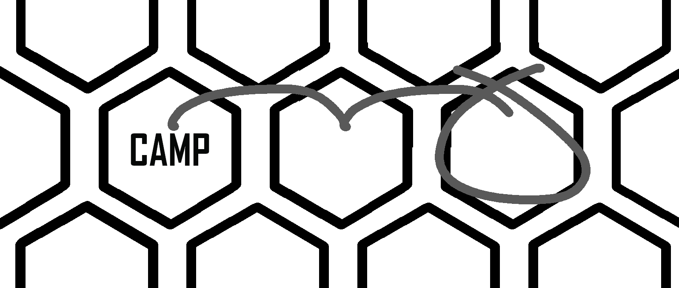
At the start of a Foraging session one of the players who have determined the fewest Foraging directions (choose randomly in the case of ties) is in charge of determining a Foraging direction on the Wilderness Map. If one of their Foraging team has a compass, they choose the direction by picking a number, if not they roll a D6 to select. They then choose a number of days to travel, which may be zero. The number of days chosen passes for all players, starting from the Foraging Team’s current location, the Foraging location is the section in the direction chosen, skipping a section for each day of travel. At first, and generally, the Foraging Team will begin from their Camp, though they may begin from their last Foraging location if they chose to remain there (see Returning to Camp, page XX).
Lou hasn’t determined before, they don’t have a compass and so roll a d6, they get a 2 and checking the key on the Wilderness Map see that means going straight right, they choose to travel for 1 day, ending up with the circled location for Foraging.
If a location has not been Foraged before, the choosing player rolls six D6 and looks up the results on the resource generation table for their zone to discover its available resources. A resource may be present more than once. They then record those resources in the six available spaces for the location.

Discover the location:
Generate a set of terrain and creatures (note that if a Predator is deployed then the second Prey deployed will be Cubs) by rolling two sets of six D6 and looking up the results on the Zone’s terrain and creatures tables, the player whose name comes immediately before that of the player who chose the Foraging location’s direction alphabetically (If a name starts with A, loop around to Z) deploys six Resource Cache tokens numbered 1-6, the terrain and creatures on the table and then chooses a table edge for the wind to be blowing from (wind direction is only relevant if creatures are present). Once terrain is deployed, beginning with the player who chose the Foraging location and following with players whose names are after them alphabetically in order (if a name starts with Z, loop around to A), players select a table edge and deploy their Foraging Team. Characters in a Foraging Team must all be deployed within 6” of each other, 4” of the chosen table edge and further than 6” from any Characters of other player’s teams. Players should move around the table to be next to the edge their team deployed on.

In The Field:
A Foraging in Survivor is broken into a number of Rounds, each Round consists of players taking Turns during which there will be a number of Character Activations. During a Round, starting with the Player who chose the Foraging location’s direction and passing around the table to their left, Players Activate their Characters one at a time, up to once each, in the order of their choice. During an Activation a Character may take up to one Move action and one Other action (either Searching or Combat). If a Character fails a test during its Activation that Player’s Turn ends immediately.
When a Player is asked to lay a Character down, simply lay it on its side. When a lain down Character activates, stand it up and reduce all of its stats by one for the activation.

Taking Tests:
At various points Characters will be asked to “Test stat” such as “Test Agility”. To do so, roll a D6 and apply any modifiers specified, if the result is above the Character’s score in the specified stat then the test is successful.

Breaking Bonds:
After rolling the dice for a test a Character may reduce the strength of one of their connections by a single stage to count that dice as the score of their choice. If this reduces their Support Bonus it should be changed immediately.

Actions:
Actions consist of a set of requirements, a success effect, support conditions and support results.

Requirements:
Requirements may designate a test if the test is successful the listed success effects take place. If no test stat is listed the success effects automatically take place.

Support:
Most actions in the field have support conditions, if a Character’s designated Buddy fulfils the support conditions the action is supported and the Support Result takes place.

Support Result:
If the Support result lists “Support Modifier” then add the Character’s Support Bonus as a modifier to any tests in the action.

Movement:
To move a model slide it along a continuous line, up to the length specified in the Move action, this is the Line Of Movement. If the final position is closer to a particular model than the starting position then that movement counts as being “towards” the model. If a straight line drawn from an acting model in a direction crosses another model, the other model counts as being in that direction. To place a model pick it up from the table and place it in the new location.

Move actions:
Walk –
Requirements:
Succeed Effect: Move up to the Character’s Move Stat in inches.
Support Conditions: Movement was towards the Buddy.
Support Result: Move up to the Character’s Support Bonus in inches.
Run –
Requirements:
Succeed Effect: Move up to double the Character’s Move Stat in inches. Gain 1 Exhaustion.
Support Conditions: Movement was towards the Buddy.
Support Result: Move up to the Character’s Support Bonus in inches.
Leap –
Requirements: Designate direction, test Agility.
Succeed Effect: Place Character up to the Character’s Move Stat in inches away in designated direction. Gain 1 Exhaustion.
Support Conditions: Buddy is in the designated direction.
Support Result: Support Modifier.
Sneak –
Requirements: Designate direction, test Agility.
Succeed Effect: Move up to the Character’s Move Stat in inches in the designated direction, lie it down. Gain 1 Exhaustion.
Support Conditions: Buddy is in the designated direction.
Support Result: Support Modifier.

Searching:

Search actions:
Search –
Requirements: Designate Resource Cache within 1”, not within 1” of enemy.
Succeed Effect: Recover Resource.
Support Conditions:
Support Result:

Recovering Resources:
To recover resources roll a D6:
1 The Resource Cache is exhausted, erase the resource from this location.
2-5 5 Roots, 1 unit of the resource listed as the Cache’s number at the location.
6 10 Roots, 2 units of the resource listed as the Cache’s number at the location.
The searching Character has any recovered resources listed on their Foraging Sheet.

Combat:

Targets:
If Character A can see Character B and Character B is within the range of a weapon Character A has equipped then Character B is an Available Target for Character A.
To perform a combat action a Character must choose an Available Target, it becomes the Designated Target.

Bare Handed:
Characters always count as being equipped with their Bare Hands, which are a weapon with a range of 0”. Characters with their bases touching each other (or close enough for convenience) count as being within 0” of each other.

Line Of Sight:
To check if a Character has line of sight to an object trace a straight line from any point on the looking Character’s head to any point on the object in question this is a Line of Sight. If any Line of Sight can be traced that does not pass through sight blocking terrain or other Characters then the looking Character can see the object.
If the object is a Character who is lying down then if any Line of Sight can be traced that passes through sight blocking terrain then the looking Character cannot see the object.
Characters have 360-degree line of sight from any part of their heads, they are individuals who can easily twist at the waist and neck to see behind them.

Combat actions:
Attack –
Requirements: Test Attack.
Succeed Effect: Hit Designated Target with weapon. Gain 1 Exhaustion.
Support Conditions: Buddy is Available Target of Designated Target.
Support Result: Support Modifier.
Push –
Requirements: Test Agility.
Succeed Effect: Move Designated Target up to 2”. Gain 1 Exhaustion.
Support Conditions: Buddy is Available Target of Designated Target.
Support Result: Support Modifier.

Hitting:
When a Designated Target is hit if the weapon’s penetration exceeds the target’s bulk, the target suffers 1 wound.

Terrain:
All Terrain should be designated with two qualities, Solidity and Opacity during set-up. Some Terrain may be designated dangerous:

Solidity:
Clear, such as open ground: No effect.
Difficult, such as undergrowth or deep snow: Each inch or part thereof of the Line of Movement traced through Difficult Terrain counts as two inches.
Blocking, such as solid rock: The Line of Movement may not cross blocking terrain.

Opacity:
Transparent, such as open air: No effect.
Obscuring, such as heavy undergrowth, blizzard weather or solid rock of less than head height: Blocks Line of Sight to lying down Characters. If any line of sight can be traced through Obscuring terrain between a Character and their Designated Target during an attack action modify the dice by -2.
Impenetrable, such as solid rock of head height or greater: Blocks Line of Sight.

Dangerous:
Danger (x): If the Line of Movement is traced through this terrain the moving model suffers x wounds, it still completes its move even if the wounds kill it.

Controlling Creatures:
Various creatures are present in the dangerous wilds of Survivor. They provide both food and other resources if successfully hunted, and in the case of apex predators, a terrible threat. They activate once per Round after all players have taken a turn, players then take turns, starting with the last player to activate a Character and passing left, choosing a creature to activate one at a time, following their behavior patterns below. Once all creatures have been activated the Round is over and a new one begins.

Line of Scent:
Creatures check if they can see objects in exactly the same way as Characters, but they can also sense them by smell. When checking for targets during a creature’s activation create a triangle by drawing a line from the creature to the table edge that the wind is blowing from, as chosen during set-up, and marking out a line of the same length along the table edge centered at the point that the first line met the table edge. Finally draw two lines back from ends of edge line back to the creature to form a triangle with the edge of the table. All Characters within this triangle are Available Targets for the creature.

Predators:
Predators begin with Standard behavior unless Cubs are present, when they will begin with Aggressive behavior. Whenever a predator is hit by an attack roll a D6, on a 1-3 if not already Aggressive or Terrified they will adopt Aggressive behavior, on a 4-6 they will adopt Terrified behavior, once they have adopted Terrified behavior, they will remain Terrified until the end of the session.
Standard – Does nothing until a Character becomes an Available Target within 6” then adopts Aggressive behavior.
Aggressive – Check all Available Targets, the creature will move up to its Move stat in inches towards the one with the shortest Line Of Movement that contacts it, stopping as soon as the Target is within range of all of its equipped weapons and then will attack the closest Available Target with the shortest range weapon it has not attacked with this turn until it has attacked with all of its equipped weapons.
Terrified – Check each table edge, the creature will move up to its Move stat in inches towards the edge with the shortest Line Of Movement that contacts it and then will attack the closest Available Target with the shortest range weapon it has not attacked with this turn until it has attacked with all of its equipped weapons.

Specific Predators:
There are predators that have more specific drives, they will list a Target Condition, if a Character fulfils those conditions the predator will follow aggressive behavior, except only Characters that fulfil the Target Conditions can be counted as Available Targets. If no Character fulfils the Target Conditions the predator will act as usual for its behavior.

Prey:
If when prey activate they have at least one Available Target roll a D6, on a 1-2 they Freeze and will count as lying down, on a 3-6 they will Flee, Check each table edge the creature will move up to its Move stat in inches towards the edge with the shortest Line Of Movement that contacts it.

Carrion:
If a creature is killed it becomes Carrion. If Carrion is searched the Character recovers the resources listed on the creature’s profile under Carrion and removes the creature.

Returning to Camp:
Characters may move off the play area at any time. When all characters have left the play area the Foraging is over.
After Foraging take the following steps, in order:
Players choose to send any amount of the foraging team back to camp with collected resources, they may leave other members in the field to forage in a new direction during the next live session.
Bind – Upgrade all connections between all characters who were on the Foraging by a single stage.
Break – Remove any characters who died, remove all connections to them. Any character with a connection to the removed character downgrades a line of connection between them and the leader for the Foraging, if they have no connections to the Foraging leader, they downgrade a line of connection between them and the Camp leader.
Then move onto a Maintaining Camp session, this can be done as a recorded session, away from other players, in a leisurely fashion.

Maintaining Camp:
Record any resources carried by returning Forage team members on the Camp Sheet. The player may choose to have any number of days pass until the next live play Foraging session, during each day that passes Characters in camp can be assigned to Crafting or Processing. For each day used all of a player’s Characters must eat, whether in camp or not to avoid Starvation.

Starvation:
Whenever a day passes, any Character that consumes a unit of food removes a point of Exposure and all Exhaustion, any that do not suffer a point of Exposure and a point of Desperation. Some food may have other effects:
Meat or Root: No additional effect.
Stew: Additional -1 Exposure.
Roast: Additional -1 Exposure and -1 Desperation.
Meal: Additional -1 Desperation, remove all Exposure, add a single line of connection to a Camp member of player’s choice.

Crafting:
Each character may work on crafting a single object during a single day. Crafting that needs Structures can only be completed if that structure is already Crafted and those needing Tools can only be completed if a Character assigned to its Crafting has that tool equipped. Required resources are consumed by crafting.

Activity:
Activities are immediately used and destroyed by the Character(s) who Crafted them when Crafted.
Required Result
Rest: 1 Character, Improved Shelters. -2 Exposure.
Recuperate: 2 Character, Medical Bay. -6 Exposure for one of the Crafters.
Fraternize: 2 Character. -1 Desperation each.
Repair: 1 Character. Return all assigned equipment’s uses to full.
Treat: 2 Character, Medical Bay, Medicine. Remove all Exposure or one Poison from one of the Crafters.

Consumables:
All Consumables are destroyed when used. They may be assigned to a Character.
Required Result
Cooked Root: 1 Character, 1 Root. 1 Stew
Cooked Meat: 1 Character, 1 Meat (3), 1 Wood (3), Fire. 1 Roast
Stew: 1 Character, X Root, Fire. As many Stews as Roots consumed.
Feast: 1 Character, 2 Root, 1 Meat (2), 1 Wood (3), 5 Meals
Fire.
Arrow: 1 Character, 1 Wood (3), 1 Stone (3). 1 Arrow
Medicine: 1 Character, 1 Man Made (3), 1 Knowledge. 1 Medicine
Clean Water: X Water, Filter. As many Clean Water as Water consumed.
Filter: 1 Fabric (3) Filter

Tools:
When constructed a Tool must be assigned to a Character, once assigned it cannot be removed.
Required Result
Bow: 1 Character, 1 Wood (3), 1 Fibre (3), 1 Bow
1 Knowledge.
Compass: 1 Character, 2 Man Made (3), 1 Knowledge. 1 Compass
Knife: 1 Character, 1 Stone (2) or Man Made (2). 1 Knife
Spear: 1 Character, 2 Wood (3), 1 Stone (3). 1 Spear

Structures:
Required Result
Fire: 3 Characters, 1 Wood (1), 1 Man Made (2). Fire
Medical Bay: 3 Characters, 2 Wood (2), 2 Fibre (2), Medical Bay
1 Man Made (3).
Processor: 3 Characters, 2 Wood (2), Processor
2 Man Made (3).
Improved
Shelters: 2 Characters, 2 Wood (2), 2 Fabric (2). Improved Shelters
Permanent
Filter: 2 Characters, 3 Wood (3), 1 Fabric (2). Filter

Tool Details:
Reach Penetration Uses Notes
Bow 12 1 5 Must consume an arrow to use.
Knife 1 1 5 Processor.
Compass - - - Allows a Foraging direction to be chosen.
Spear 2 2 5

Uses:
Whenever a tool with uses is used during a Foraging roll a D6, on a 1 reduce its uses by 1, if its uses reaches 0 it is destroyed.

Processing:
All resources have a rank listed in brackets, either 1, 2 or 3 with 1 representing the largest and often least processed version of a resource and 3 the smallest. In the case of wood 1 would be a log, 2 a plank or split log and 3 a stick or branch. Crafting will require a number of resources of a given rank. A single resource may be used to fulfil the requirement for any single resource of its rank or lower. Resources cannot be used to fulfil the requirement for a higher rank resource, even in large amounts. For example, a Wood (1) resource can fulfil the requirement for Wood (1) (2) or (3), but it would not fulfil the requirement for 2 x Wood (3).
A single character with a Tool that has the Processor rule or any number of characters using a Structure that has the Processor rule may spend a day processing any amount of a single resource type into a quantity of resources of a single rank lower on a two for one basis. Alternatively, they may use them to render an existing tool or structure back to its required resources.

Environments:
Survivor recreates the story of a desperate struggle against extreme and deadly environments as much as other humans. To create a set of resource, creature and terrain tables select three of the following pairs of terms and then choose one from each of them, record the results in the spaces on the Wilderness Map. Each will include a special rule for use during Foraging. For example, players could agree to re-create a lost group of Arctic explorers, finding supplies from previous expeditions with Cold, Barren, Modern or to live the life of a neanderthal in teeming jungles with Wet, Fecund, Pre-Historic.

Wet/Dry:

Wet:
Resources – Water, Wood
Creatures – Predator, Prey
Terrain – Swamp (Difficult, Transparent, Danger (1)), River (Difficult, Transparent)
Special Rules – Whenever a tool loses one Use it loses a second Use.

Dry:
Resources – Stone, Nothing
Creatures – Prey, Nothing
Terrain – Sand Dune (Difficult, Obscuring), Dry Riverbed (Difficult, Transparent)
Special Rules – Characters with six Exhaustion suffer 1 Exposure each action.

Hot/Cold:

Hot:
Resources – Fabric, Nothing
Creatures – Prey, Nothing
Terrain – Rock Formation (Blocking, Impenetrable), Dead Plants (Difficult, Obscuring)
Special Rules – Double all exhaustion gains.

Cold:
Resources – Water, Stone
Creatures – Predator, Nothing
Terrain – Snow Drift (Difficult, Obscuring), Fissure (Clear, Transparent, Danger (3))
Special Rules – Characters suffer 1 Exposure each activation.

Fecund/Barren:

Fecund:
Resources – Wood, Fabric
Creatures – Predator, Prey
Terrain – Heavy Undergrowth (Difficult, Impenetrable), Light Undergrowth (Difficult, Obscuring)
Special Rules – Characters passing through Difficult Terrain suffer Poison 1 on a D6 roll of a 1.

Barren:
Resources – Nothing, Nothing
Creatures – Nothing, Nothing
Terrain – Nothing, Nothing
Special Rules – When searching, subtract one from the recover resources roll.

Pre-historic/Modern:

Pre-historic:
Resources – Stone, Wood
Creatures – Mammoth, Prey
Terrain – Stone Outcrop (Blocking, Impenetrable), Cliff (Clear, Transparent, Danger (5))
Special Rules – All Predators gain +1 bulk

Modern:
Resources – Man Made, Knowledge
Creatures – Prey, Nothing
Terrain – Plane Wreckage (Difficult, Obscuring), Supply Crates (Difficult, Obscuring)
Special Rules – During Discover the Location roll a D6 for each Nothing resource, on a 6 generate a new resource for it.

Ending the Story:
It is entirely possible that the story is resolved by virtue of there being only one Camp remaining. Alternatively, during the crafting phase a player may destroy all of their structures and consume one food per Character to move their Camp to an adjacent location on the Wilderness Map, Characters may be forced to desert (or killed if incapacitated) to save food if desired. If a Camp leaves the Wilderness Map, they have found their way back to civilization (or whatever passes for it in their world) and are saved. The fates of any other camps are unlikely to be so rosy…

Factions:

Officer Led:
Cult of Personality:

Deeper Darkness:

Betrayal:

Supernatural Threats:

Terrible Locations:

Insanity:

Bestiary:
Human:
Movement Agility Attack Bulk Wounds
3 3 5 0 1
Prey:
Movement Attack Bulk Wounds Carrion
8 2 0 1 Meat (2), Fabric (2)
Predator:
Movement Attack Bulk Wounds Carrion
4 2 1 2 Meat (1), Fabric (1)
Mammoth (Predator):
Movement Attack Bulk Wounds Carrion
4 1 3 5 4 x Meat (1), 4 x Fabric (1)
Cubs (Prey):
Movement Attack Bulk Wounds Carrion
4 6 0 1 Meat (3), Fabric (3)

