Turing
Version 1.02 – 30/01/2021
If a human engages in a conversation with a machine and is convinced the machine is in fact human then that machine can be said to have exhibited intelligence. This is the most basic formulation of the Turing Test of artificial intelligence. What then of the human that fails to convince someone else that they are not a machine over the same test? What if communication can be sufficiently occluded to stop someone from being able to identify as human at all? Welcome to Turing.
In Turing there are two sides to each communication, the Interrogator and the Responder. The Responder will hand the Interrogator a series of Responses, some of which they will have selected while the others are randomly generated by the Machine. If the Interrogator is able to successfully identify which Responses come from the Responder both Interrogator and Responder will score.
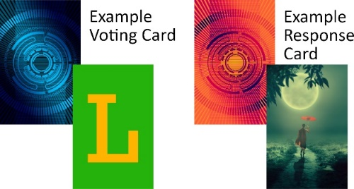
Set-up:
Place the Voting cards with the black backgrounds face up on the table to indicate R group and L group, it may save confusion if they are oriented with the R on the right and the L on the left from the Interrogator’s point of view. Choose a colour, find and draw the two voting cards of that colour. Decide to play Competitive or Co-operative mode and pick a player to be the first Responder, the Responder may not talk during play. Hand the Responder the Shield.
Round Start:
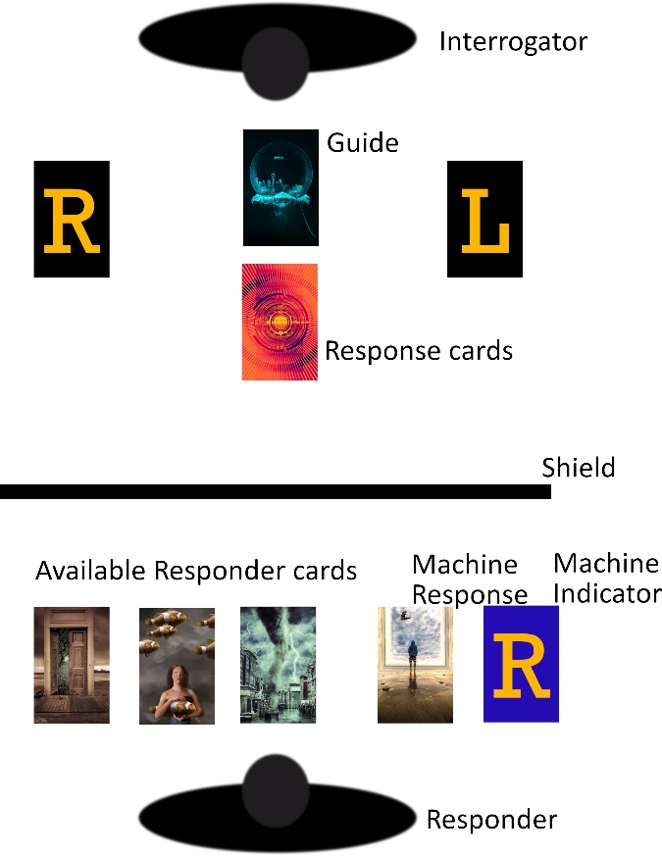
The chosen Responder stacks their Voting cards face down shuffles them and draws one, this indicates the Machine’s card, either (R) Right or (L) Left. Flip the top Response card to act as the Guide.
Gameplay:
The Responder draws four Response cards (three if you want to play hard mode, five for easy mode), one at a time, and sets them in a row from left to right behind the Shield. Either the rightmost or leftmost card is the Machine’s Card, as indicated by the Voting card they drew during Round Start. Of the remaining cards they should choose one as theirs (if they wish, using the Guide to help them), then discard the remaining cards face-down (two cards at standard difficulty). They should have two cards remaining, stack them with the left most card on top and the right most card underneath, then hand them to the Interrogators. The Interrogators then place the top card of the stack they receive face-up next to the L and the bottom card face-up next to the R. Repeat drawing, choosing and placing three times.
The Interrogators then choose one of the two groups of three cards they can now see and select the Voting card indicating its group, R or L, placing the Voting card face down (they should feel free to discuss what they see as evidence of intent in the cards and their reason for voting one way or another). Once all Interrogators have selected a group reveal their votes and the round is over, score the round according to your chosen play mode.
Scoring:
Use face down Response cards to track points with one card representing one point, keep track of points gained from rounds playing as the Responder (turning them sideways works well).
Scoring Standard Competitive Play (3-6 Players Competitive):
Each Interrogator which has identified the Responder’s group scores one point, the Responder scores one point for each Interrogator that has correctly identified their group.
Scoring Co-operative Play (2-6 Players Competitive):
If the majority of Interrogators correctly identify the Responder’s group, the players score a point.
Scoring Gnirut Play (2 Players Competitive/Alternative Competitive):
Each Interrogator which has identified the Responder’s group scores one point.
Round End:
The player on the Responder’s left is the new Responder, hand them the shield, shuffle all Response cards together and return to Round start.
Game End:
Ending Standard Competitive or Gnirut:
Continue until one player has at least five points at the end of a round, then continue to play until every player has had at least one turn as the Responder (which may be immediately) and end the game, the player with the highest score wins, in the case of a draw the most points scored as Responder breaks ties.
Ending Co-operative:
Continue until each player has been the Responder twice, then total the score, if it is greater than the number of players all players win.

