Crash T.V.

The Skirmish Game of Co-operative struggle.

Contents

The Game. 4

What you’ll need. 4

What’s what. 5

Rules of the Game. 5

Measures of Communication. 5

It’s in the cards. 5

Timing is everything. 6

The Way you Move. 6

Birthjacking. 8

Right hand Equipment. 8

Left Hand Equipment. 8

Stats 8

The Deck 9

Pre-production. 10

Show Running. 10

Scripting. 10

Action. 10

♥ Move. 10

♣ Shoot. 10

♦ Act. 10

♠ Think. 10

Episodes. 11

The Core. 12

Equipment Check. 12

Set Design. 12

Exciting Challenges. 12

End Credits. 13

Big Money Prizes. 13

Kill Count. 14

Equipment Check. 14

Set Design. 14

Next Challenge. 14

End Credits. 15

Big Money Prizes. 15

Pinball People Pool. 16

Equipment Check. 16

Set Design. 16

Next Challenge. 16

End Credits. 16

Big Money Prizes. 16

Top Sheepleherder. 18

Equipment Check. 18

Set Design. 18

Next Challenge. 18

End Credits. 19

Big Money Prizes. 19

Soylent Stars. 20

Seasons. 21

Pilot. 21

Behind the Scenes. 21

Ratings 21

Sharing 22

Growing 22

Scheduling 22

Contacting the Resistance. 23

Equipment Check. 23

Set Design. 23

Exciting Challenges. 24

End Credits. 24

Big Money Prizes. 24

*Don’t touch that dial, don’t change that channel, don’t think too hard, get up and move around or consider rising in armed rebellion, its Crash T.V! Running 24 hours a day and showing the most action filled shows full of confusingly juxtaposed lights, images and sounds, it’ll keep you happy and disorientated, Crash T.V! Crash T.V! Crash T.V!*

# The Game.

Crash T.V. is a **co-operative** tabletop miniatures game set within a hyper violent futuristic television studio. Players will take the part of contestants on brutal game shows, forced to strap on body cams and risk their lives for the entertainment of a paying audience. They will need to judge their partner’s intentions and abilities during play and choose how best to co-ordinate accordingly.

Crash T.V. uses cards rather than dice to generate random numbers, each player has their own deck of cards. If a player’s deck runs out, they will be **Eliminated**. If a contestant is eliminated for any reason, it’s miniature is removed from play. Before a game players will pick an episode that they are competing in, each episode has specific conditions for winning and losing, but generally if only one contestant remains players **fail**.

## What you’ll need.

To play Crash T.V. each player will need:

A deck of normal playing cards.

A tape-measure.

A miniature representing their contestant, it should ideally be more or less humanoid and around 25-32mm tall.

An “After-image” token, which is any token the same size as the miniature’s base which can be identified as matching to it.

The players will need between them:

A set of miniatures or markers representing various threats and obstacles based on the episode being played, check the episode’s **Set Design** set-up conditions. Many of the necessary pieces can be copied from the last page of these rules or downloaded from our website and printed off for simple two-dimensional versions.

A handful of normal six-sided dice used to represent interactive objects of an episode’s set design.

A 2’x2’ playing surface.

## What’s what.

The miniature representing a player is their **contestant**.

The other players are **partners**.

Non-contestant miniatures are **obstacles**.

All miniatures are **objects**.

# Rules of the Game.

## Measures of Communication.

During a session of Crash T.V. communication between players is controlled, they should never talk about their plans for any turn apart from the current one. During the Scripting phase of a turn, they can only refer to the game or their intentions within it in general terms:

* Direction – Only by a single cardinal direction, North, South, East or West or relative direction, Forwards, Backwards, Left or Right.
* Timing – Only as Early, Middle or Late.
* Intent – Only as Move, Stop or Shoot.

Players may measure freely, but only from the current position of a contestant to any other point, they must not measure the distance between intended or future positions.

## It’s in the cards.

Crash T.V. uses cards rather than dice to generate random numbers, along with many other things.

Each player should have their own **Deck**, built by selecting a number of cards from a standard 54 card deck, including jokers, equal to their character’s resilience. They should shuffle and keep their deck face down next to them to flip and draw cards from. Each player should also have their own **Discard Pile** of used cards, kept face up next to their deck.

When asked to **Draw** a card, a player simply takes the top card of their deck into their hand.

When asked to **Flip** a card, a player reveals the top card of their deck, resolves and discards it.

When the rules state “C” followed by a number, the player controlling the active contestant flips the top card of their deck and uses it to generate a number:

* C4: ♣ =1; ♦ = 2; ♥ = 3; ♠ = 4.
* C7: Half face value rounded up. Jack = 11, Queen = 12, King = 13.
* C13: Face value, Jack = 11, Queen = 12, King = 13

Jokers are always wild and may be counted as any single card the player wishes.

When the rules state “TC” followed by a number, the player uses the Timing Card that is currently being resolved to generate the number.

*For example, Ben is asked to generate a C4 result, he flips the top card of his deck and gets a ♥ for a 3. Later on he fires his Grappler at his partner, it moves them TC7 so Ben checks his Timing Card to see a 10 and so moves his partner 5” directly towards him.*

After a card is flipped or otherwise resolved move it to the player’s discard pile.

If asked to randomly place something using a card, place the card face up on the table, then spin it. When it comes to rest draw a line through its two numbers or letters, measure along the line which extends from the card corner furthest from a table edge C13”, using the card to generate the number. The point arrived at is the random point, stop 2” before any table edge.

If a player would ever be asked to draw or flip a card and their deck is empty, they are **Eliminated**.

## Timing is everything.

Contestants are activated by their **Timing Stack**, a pre-built stack of playing cards that will be flipped to activate a contestant. Players must think ahead and predict their partner. The timing stack must remain in order unless a player is specifically allowed to re-arrange it, in which case they may look at the stack before re-arranging it. Otherwise, the timing stack is kept face down.

When asked to **Write the Script** at the start of an episode players choose two cards from their hand and place them one on top of the other as their timing stack.

When asked to **Extend Time** payers place a card in their hand on the bottom of their timing stack.

When a contestant takes damage, it will be stated as **Damage (X)** with X as a number. The player controlling the contestant discards a number of cards from their timing stack equal to the damage number.

If a contestant needs to discard or flip from their timing stack when it is empty, they should take them directly from their deck. This means that a contestant which takes too much damage will start acting unpredictably as they flip random cards for their deck for their actions.

## The Way you Move.

When contestants **Walk,** they travel with their base centered on their forward line. To find a contestant’s forward line draw a line from the centre of the model’s base extending through its right hand, this is its forward line. They must move at least half the available distance, rounding down and can move up to the available distance. If they contact an object, they stop and take Damage (1).

At times a contestant may shoot a partner with one or another weapon that causes them to jump. When contestants **Jump,** they travel with their base centered on a straight line drawn between the center of their base and that of the shooter. They move the whole available distance, ignoring all obstacles. If they end overlapping an obstacle move them the minimum possible amount in a straight line back towards their original position until they are not overlapping it, then they take Damage (1).

At times a contestant may shoot an object with one or another weapon that drags them around. When contestants **Drag** an object**,** it travels with its base centered on a straight line drawn between the center of its base and that of the shooter. It moves the whole available distance.

Whenever a contestant walks or jumps, before they move place their **After-Image** token touching their base. The line between the center of an object’s base and the center of their after-image token is their **Ghost**.

If a contestant ever leaves the playing area for any reason they are **Eliminated**.

# Birthjacking.

*And our next contestant is Sandra. Sandra is a simp processor from the King Cole Burgers corp. pools of the Rio favelas. Her interests are quality meat sandwich products and avoiding high intensity electric shocks. Well Sandra, every CTV Viewing Parlor™ carries King Cole Burger concession stands, so one out of two isn’t bad.*

Players should build their contestant by selecting one right hand equipment, one left hand equipment, three stat boosts and then building their deck.

## Right hand Equipment.

Right hand equipment’s specific effects vary depending on the episode being played. Specific abilities will be set in the Equipment Check section of an episode.

Boomer - The phase shifting Boomer is named for its distinctive noise when fired, targets have their atoms quantum shifted, allowing them to temporarily walk-through objects. It results in fewer additional effects, but allows for more flexibility if co-ordination is not ideal.

Grappler - The grappler fires a “mostly” painless flesh hook which yanks the target violently forward while attaching a small but effective parachute, essentially paragliding them forwards. It provides additional benefits if a team is well coordinated, but can cause problems if partners get out of sync.

Slammer - The slammer fires a not at all painless concussive blast, along with a small parachute, causing its target to fly backwards through the air. It provides additional benefits if a team is well coordinated, but can cause problems if partners get out of sync.

Disintegrator - The disintegrator causes things to disintegrate, which is pretty scary, it does it somewhat randomly, which is more or less terrifying. It provides useful effects even if a team is totally out of sync and can even be effective solo, but its results can be unpredictable, sometimes entirely useless, or worse.

## Left Hand Equipment.

Time Dilator - Move this contestant’s After-image token up to TC7” in any direction.

Mini-com - Re-arrange this contestant’s timing stack.

Memorizer - Flip a card, then draw up to TC7 discarded cards.

Replicator - Activate partner’s current card, during this activation count as having their equipment. If partner has a Replicator, treat it as the left hand equipment of your choice.

## Stats

Players may apply up to three boosts, which can be applied to the same stat multiple times. Starting contestant stat lines look like this:

|  |  |  |  |  |  |  |
| --- | --- | --- | --- | --- | --- | --- |
|  | Speed | Intelligence | Control | Tech | Resilience | Likeability |
| Boost | +2 | +1 | +1 | +1 | +5 | +1 |
| Base Stat | 0 | 3 | 2 | 0 | 20 | 1 |

**Speed** – The extra distance a contestant moves.

**Intelligence** – How many cards a contestant draws at the start of an episode.

**Control**  – How much control a contest has over their timing and actions.

**Tech** – How good the contestant is at interacting with the tech stations in the show.

**Resilience** – How much damage the contestant can take or how long they can remain active for before being Eliminated.

**Likeability**  – How much the audience will look to save the contestant.

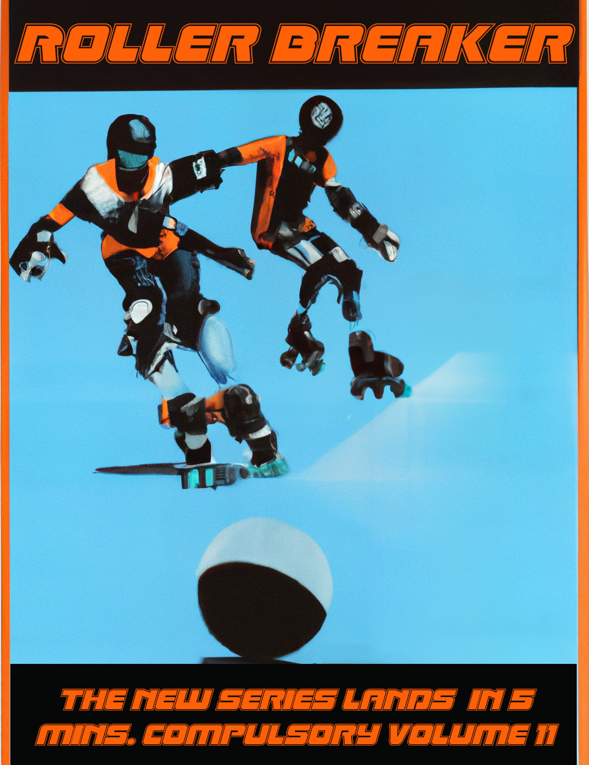**Audience Votes**: Each round, each point of likeability allows the player to raise or lower a card score by one.

## The Deck

Choose a number of cards equal to your contestant’s resilience from a standard 54 card deck (including jokers) to form your contestant’s deck.

# Pre-production.

Before beginning a game of Crash T.V. lay out any obstacles as specified in the current episode’s description along with the contestants. Each player shuffles their deck and draws as many cards as their intelligence score then Write the Script by stacking two of them as their Timing Stack.

# Show Running.

A game of Crash T.V. consists of a number of rounds, each round consists of a single Scripting phase and Action phase.

## Scripting.

During the Scripting phase of a Crash T.V. round players may only communicate with controls. Each player Extends Time then draws a card.

## Action.

Both players flip the top card of their Timing Stack, they may raise or lower its value by their contestant’s control stat then the player with the lowest value card goes first, moving up through card values. The suit and value of the card will define the contestant’s action.

## ♥ Move.

The contestant walks, taking TC7 plus their speed as the available distance, then pivots as much as the player wishes.

## ♣ Shoot.

The contestant shoots their right hand equipment along its forward line. The closest barrier, object or contestant who is or has their ghost under the line is tagged by the equipment.

## ♦ Act.

The contestant uses their left hand equipment.

## ♠ Think.

The contestant draws TC7 card then Extends Time up to TC7 times.

# Episodes.

Either select an episode or flip a card to choose an episode before shuffling it back into its deck.

|  |  |
| --- | --- |
| ♥ | The Core. |
| ♠ | Kill Count. |
| ♣ | Pinball People Pool. |
| ♦ | Top Sheepleherder. |

# The Core.

*Franchised around the world, but never bettered, welcome to our 118th ratings busting season of The Core. We take the finest birthjacked candidates from a range of Oligarchy corp. pools, offer them barely sufficient training and see if they can work together with total strangers in order to beat the core. And as all fans know, eventually, the CORE ALWAYS WINS!*

## Equipment Check.

Boomer - Tagged contestant ignores obstacles during their next move.

Grappler - Tagged contestant jumps TC7” directly towards shooting contestant.

Slammer - Tagged contestant jumps TC7” directly away from shooting contestant.

Disintegrator- Remove from play C4th object along forward line (including contestants, who are eliminated) counting away from the shooting contestant.

## Set Design.

*Today’s core has been designed by Annabelle Stanski of Tallahasse. Annabelle registered with The Core just fifteen minutes ago and now stands to receive fabulous prizes so why not join her? Registration is free and requires only genome and first level brain stem scans. Annabelle is almost nine, so you know this is going to be a killer core!*

The Core requires five dice representing Cores and 20 4” long barriers, which can be any object 4” long and no more than 1” across, of any height players wish. Appropriate barriers are included at the end of this book which you may copy, cut out and use.

Place a six-sided dice showing 1, representing the Main Core, in the middle of the playing surface.

Divide the table into 4 equal squares, place a six-sided dice showing 1, representing the Partial Cores, in the middle of each of these squares.

Place four 4” long barriers in a square around each Core.

Place each contestant within 3” of the corner of the playing area of its controller’s choice.

## Exciting Challenges.

*And that’s Rick, our volunteer firefighter, barrio dweller and father of six and he’s putting his all into engaging with that core. I’m thinking he wants to avoid another of those Core shocks now we’re up to 10,000 volts and… ooooh! Crotch bolt! Well, here’s hoping Rick was always planning on stopping at six.*

If a contestant is in base contact with a Core at the end of their activation, they may flip C4 and add their Tech, if the result is 3 or greater remove the Core in base contact with them. If the result is 2 or less, they suffer damage (X) where X is the current value showing on the Core’s dice, then raise all Core dice by 1, to a maximum of 6. The Main Core may not be removed if there are any Partial Cores in play.

If a Core is removed pivot the two barriers around it closest to the main core 90 degrees around the point of the barrier closest to the main core.

## End Credits.

Play continues until either all Cores are removed or one or fewer contestants remain.

If one or fewer contestants remain the players lose.

## Big Money Prizes.

If all the Cores are removed the players win.

# Kill Count.

*The Simp-Growns™ are warm, the contestants are hyped and the studio has been mostly hosed down. Place your limb cam™ bets to play along at home and remember, it’s all about the… Kill Count!*

## Equipment Check.

Boomer - Tagged object is removed the next time it contacts an object.

Grappler - Tagged object is dragged TC7” directly towards shooting contestant.

Slammer - Tagged object is dragged TC7” directly away from shooting contestant.

Disintegrator - Remove from play C4th object along forward line (including contestants) counting away from the shooting contestant.

## Set Design.

*As always, all Simp flesh from tonight’s contest will be mechanically reclaimed and processed into delicious food nuggets. The only meat that raises itself and butchers itself, Simp meat is the best meat, the answer to all your problems. Tonight’s Simps will be rendered into mouth watering KFS popcorn bites, so why not pick some up during the show, you might be eating a star!*

Kill Count requires at least five objects (ideally rather mindless looking humanoid miniatures) to represent Simps and five matching Simp After Image tokens.

Place each contestant within 3” of the corner of its controller’s choice and four Simps evenly spaced in a line traced between two diagonally opposite corners of the table where the line starts and ends 8” away from the table edges. Place an object no more than 1” square representing a studio terminal within 3” of any corners that do not have contestants in them.

## Next Challenge.

Players may choose to place Simp after image tokens before a Simp is dragged, if they choose not to place a token for a Simp that has one in place the existing token stays in place. A Simp with an after image in place can only move by being dragged. If a Simp ends a drag closer to its after image than it began, remove it.

At the start of each round choose a player to flip a card then move all Simps in the order of the player’s choice according to the flipped card:

* - North C7”
* - East C7”
* - South C7”
* - West C7”

If a Simp contacts a contestant or visa-versa the contestant takes Damage (1). If a Simp leaves the playing area it is removed. Whenever a Simp is removed for any reason add 1 to the Kill Count. At the end of any round when at least one Simp was removed, add two Simps evenly spaced in a line traced between two diagonally opposite corners of the table.

If a contestant is in base contact with a studio terminal at the end of their activation, they may flip C4 and add their Tech, if the result is 3 or greater then at the start of the next round no card is flipped and players may choose the suit and card value for Simp movement.

## End Credits.

Play continues until either there are 6 or more Simps at the end of a round, the kill count reaches 11 or more or there are one or fewer contestants remaining.

If one or fewer contestants remain the players lose.

## Big Money Prizes.

When play ends, check the Kill Count.

1-2 - Pathetic (Loss)

3-4 - Poor (Loss)

5-6 - Acceptable (Draw)

7-8 - Good (Win)

9-10 - God (Win)

11+ - God calls you God (Win)

# Pinball People Pool.

*Our contestants have been sealed in their patented Boooingo™ balls, guaranteed to protect them from collisions, impacts, falling damage and having more than 20 minutes of oxygen. Should they score highly enough to claim total victory we’re almost certain we can cut them out again too. Its time to play pinball people pool, so roll ‘em!*

## Equipment Check.

During Pinball People Pool treat shoot results as move results with the following additional effects:

Boomer - Ignore up to one contact this activation.

Grappler - After one contact this activation move the contacting object up to TC7” away from the contacted object after completing any collision movement.

Slammer - After one contact this activation move the contacted object up to TC7” after completing any collision movement.

Disintegrator - On the C4th contact this activation, count all objects within 3” of the contact as being contacted.

## Set Design.

Pinball People Pool requires up to five circular objects (round bases work quite well) to represent pinballs with matching After Image tokens.

Place each contestant along with enough circular objects to total six overall objects in an equal sided triangle centered on the playing area.

## Next Challenge.

Whenever an object would cross a ghost or other object it stops, this is a contact. The contacted object moves any remaining distance directly away from the contacting object.

Whenever two objects make contact with each other increase the score by one. Whenever a contestant contacts an object, they suffer Damage (1).

## End Credits.

Play continues until either no-non contestant objects remain, the score is 21 or more or one or fewer contestants remain.

If one or fewer contestants remain the players lose.

## Big Money Prizes.

When play ends, check the score.

1-4 - Pathetic (Loss)

5-8 - Poor (Loss)

9-12 - Acceptable (Draw)

13-16 - Good (Win)

17-20 - God (Win)

21+ - God calls you God (Win)

# Top Sheepleherder.

*We’ve had a fine day of herding the finest Soylent folk here today and you’ve all seen them run terrified into our wide range of entertainingly “humane” mincers, manglers and Soylent soup liquidisers™. Sure, some of our contestants have been savaged by Soylents, but remember, “Feelings don’t count if they’re Soylent, but flavours sure do!”.*

## Equipment Check.

Boomer - Tagged object ignores all ghosts and objects the next time it moves.

Grappler - Tagged object is dragged TC7” directly towards shooting contestant.

Slammer - Tagged object is dragged TC7” directly away from shooting contestant.

Disintegrator - Tagged object either ceases movement or ignores ghosts for the rest of the episode.

## Set Design.

Top Sheeplherder requires at least five objects (ideally rather mindless looking humanoid miniatures) to represent Simps and five matching Simp After Image tokens.

Place each contestant within 3” of the corner of its controller’s choice.

Place a Simp, in the middle of the playing surface. Divide the table into 4 equal squares, place a Simp in the middle of each of these squares.

Draw a line from the middle of each table edge to the middle of the opposite edge, place an object no more than 1” square representing a studio terminal one and two thirds of the way along each of these lines.

## Next Challenge.

Simps have after image tokens placed when moving as if they were contestants. Each Simp has a starting Meat value of 1.

At the start of each round choose a player to flip a card then move all Simps TC7” such that they end the move further away from all contestants and contestant’s ghosts, if there are two or more moves that would achieve this, they choose the move that would end closest to the nearest other Simp that would result in a single path being chosen.

If two Simps contact each other remove the Simp of the players’ choice and increase the remaining Simp’s Meat value by the Meat value of the removed Simp. If a Simp leaves the playing area it is removed.

If a contestant is in base contact with a studio terminal at the end of their activation, they may flip C4 and add their Tech, if the result is 3 or greater that terminal is activated. If a Simp contacts an active terminal the players score its Meat value and remove it.

Whenever a Simp is removed, place a new Simp with a Meat value of 1 as close as possible to the middle of the table while being at least 7” from all other Simps.

If a contestant contacts a Simp or a Simp’s ghost remove the Simp, the players score its Meat value then remove the Simp.

## End Credits.

Play continues until either the score is 14 or more or one or fewer contestants remain.

If one or fewer contestants remain the players lose.

## Big Money Prizes.

When play ends, check the scored Meat value.

1-3 - Pathetic

4-6 - Poor

7-9 - Acceptable

10-12 - Good

12-13 - God

14+ - God calls you God

# Soylent Stars.

In order to play Crash T.V. with more contestants than there are players available one or more contestant can be designated Soylent Stars. A player should build any Soylent Stars using the usual Birthjacking rules, note that for Soylent Stars Intelligence has a different function than normal contestants. Soylent Stars:

* Have no Timing Stack. When asked to flip a Timing Stack card (which will come directly from their Deck) the Soylent Star’s partner may opt to flip another card, as many times as they wish. The new card replaces all previously flipped cards as the new Timing Stack card.
* May, throughout a game, shuffle up to as many cards as their Intelligence stat in total back into their deck if their partner wishes.
* Always move the full amount when moving. They always pivot towards the nearest Core, Pinball, Simp or Partner, whichever is closest.

# Seasons.

## Pilot.

*I dreamed I won The Core. Everyone cheered, I was a hero. It must have been a dream, because if I’d won, I’d be a millionaire. It must have been a dream because I remember it, but I don’t remember ever going to sleep.*

*I won the lottery; I’m going to be on The Core. Is the dream coming true?*

It is possible to play Crash T.V. as a series of connecting games, in fact doing so can offer a deeper range of challenges and stories. The truth of Crash T.V. is that it is a form of state execution for suspected seditionists (along with any number of unfortunate and innocent contestants, because the studio needs cover) among a population of clone generations. Clone records are constantly and automatically updated and continually degrading, can your contestants learn the truth about Crash T.V. and escape their fate before they collapse into genetic sludge?

To play a Crash T.V. season each player will need a permanent marker of some kind, they should also note that the seasons system will ask them to write on the cards of their deck, do not use a deck that it would make you sad to scribble on.

Create your contestant as normal, they will have two additional statistics, Memory and Trust, both of which begin at 0. Whenever a contestant is eliminated, they immediately lose all Memory and Trust, reverting to 0.

## Behind the Scenes.

*As I’m walking out to the studio, I notice written within the cuff of my jumpsuit in blood a short phrase “No 1 wins”. It starts be thinking about the fact that in the shows its all blunt trauma and electrical shocks. Things that kill the person without ruining the props and costumes. That’s really got me thinking.*

*The words written in my cuff are in my handwriting. That’s got me thinking too.*

After a season game of Crash T.V. there are an additional set of steps:

Ratings - During which the previous game’s events are examined and converted into stat raises and other effects.

Sharing - During which contestants may wish to trust each other.

Growing - During which contestants may become better a competing.

Scheduling - During which a new episode is generated.

### Ratings

Depending on the events that just took place, after a season game of Crash T.V, various points need to be adjusted:

If at least two contestants survived, they all gain 1 Trust.

All surviving contestants gain 1 Memory.

All surviving contestants gain 1 Boost if they did not fail the episode.

The contestant who removed the most Cores or scored the most points gains 1 Boost.

### Sharing

A player may choose to share with any partner that was not eliminated during the game. To do so, each player selects a card from their deck, then reveals them. If the cards are of the same suit the share was successful, the contestant with the lowest memory raises their memory score to that of the other player. If the cards are of a different suit reduce both contestant’s Trust by 1, if either contestant has a Trust of 0 the sharing has gone badly, the contestant with the higher memory score is eliminated. Players may continue to attempt to share so long as both contestants have a trust of at least 1, repeating the process.

### Growing

Players may spend any boosts exactly as they did during birthjacking to raise stats. In addition, if a contestant was eliminated during the previous episode, surviving contestants may spend a boost to gain the eliminated contestant’s right or left hand equipment in addition to their own.

If a contestant was eliminated, take an unused card from their deck and mark it with a large black cross before adding it to their deck. When a card with a black cross is flipped or otherwise resolved it counts as having a value of zero and no suit. When a card with a black cross is flipped or otherwise resolved immediately raise the active contestant’s memory by 1.

A player may spend 2 Boosts to add a suit to a card of their choice in their deck. They may spend 1 Boost for each pip on a card in their deck to add a single additional pip to the card.

### Scheduling

Before the next game flip, a C13, if the result is equal or higher than the highest memory value of any contestant select and play an episode as normal. If the result is between half and less than the highest memory value whenever a contestant succeeds in operating a studio terminal or core during the next episode, they may increase their memory by 1 rather than gain any other effect. If the result is half the highest memory value or less, its time to do something about what’s going on, instead of a normal episode, play Contacting the Resistance as the next game.

## Contacting the Resistance.

*There is an old uplink buried in the studio with which it might just be possible to contact someone who can get me out of this. As I make my way there, I feel as though I recognize everything coming at me, like someone has been training me for this.*

## Equipment Check.

When right hand equipment is used while contacting the resistance select an effect:

Boomer - Tagged contestant ignores obstacles during their next move.

- Tagged object is removed the next time it contacts an object.

- Walk, taking TC7 plus their speed as the available distance, then pivot as much as the player wishes, ignoring up to one contact.

Grappler - Tagged contestant jumps TC7” directly towards shooting contestant.

- Tagged object is dragged TC7” directly towards shooting contestant.

- Walk, taking TC7 plus their speed as the available distance, then pivot as much as the player wishes, after one contact this activation move the contacting object up to TC7” away from the contacted object after completing any collision movement.

Slammer - Tagged contestant jumps TC7” directly away from shooting contestant.

- Tagged object is dragged TC7” directly away from shooting contestant.

- Walk, taking TC7 plus their speed as the available distance, then pivot as much as the player wishes, after one contact this activation move the contacted object up to TC7” after completing any collision movement.

Disintegrator - Remove from play C4th object along forward line (including contestants, who are eliminated) counting away from the shooting contestant.

- Remove from play C4th object along forward line (including contestants) counting away from the shooting contestant.

- Walk, taking TC7 plus their speed as the available distance, then pivot as much as the player wishes, on the C4th contact this activation, count all objects within 3” of the contact as being contacted.

## Set Design.

Contacting the Resistance requires:

* Five dice representing Studio Terminals.
* 20 4” long barriers, which can be any object 4” long and no more than 1” across, of any height players wish. Appropriate barriers are included at the end of this book which you may copy, cut out and use.
* Four objects (ideally rather mindless looking humanoid miniatures) to represent Simps and four matching Simp After Image tokens.

Place a six-sided dice showing 1, representing the Uplink, in the middle of the playing surface.

Divide the table into 4 equal squares, place a six-sided dice showing 1, representing studio terminals, in the middle of each of these squares.

Place four 4” long barriers in a square around each studio terminal and the uplink.

Place a Simp next to each of the four corners of the barriers around the uplink.

Place each contestant within 3” of the corner of the playing area of its controller’s choice.

## Exciting Challenges.

If a contestant is in base contact with a studio terminal or uplink at the end of their activation, they may flip C4 and add their Tech, if the result is 5 or greater remove the terminal or uplink in base contact with them. If the result is 4 or less, they suffer damage (X) where X is the current value showing on the terminal or uplink’s dice, then raise all dice by 1, to a maximum of 6. The Uplink may not be removed if there are any terminals in play.

If a terminal is removed pivot the two barriers around it closest to the uplink 90 degrees around the point of the barrier closest to the uplink, lifting them over any objects in the way.

Players may choose to place Simp after image tokens before a Simp is dragged, if they choose not to place a token for a Simp that has one in place the existing token stays in place. A Simp with an after image in place can only move by being dragged. If a Simp ends a drag closer to its after image than it began, remove it.

At the start of each round choose a player to flip a card then move all Simps in the order of the player’s choice according to the flipped card:

* - North C7”
* - East C7”
* - South C7”
* - West C7”

If a Simp contacts a contestant or visa-versa the contestant takes Damage (3). If a Simp leaves the playing area it is removed. At the end of any round when at least one Simp was removed, place one Simp next to the corner of the barriers around the uplink closest to the removed Simp’s final position.

Whenever an object would cross a ghost or other object it stops, this is a contact. The contacted object moves any remaining distance directly away from the contacting object.

## End Credits.

Play continues until either the uplink is removed or no contestants remain.

If no contestants remain the players lose.

## Big Money Prizes.

If the uplink is removed the players win.

*Congratulations! You are the winner of Crash T.V, the latest death sports and reality show! You have won a fabulous cash prize by displaying all the skills needed to lead an uprising against our sponsors. Please put on the tension maintaining blindfold and the safety handcuffs and follow the heavily armed guards into the sound proof windowless room to collect your prize.*

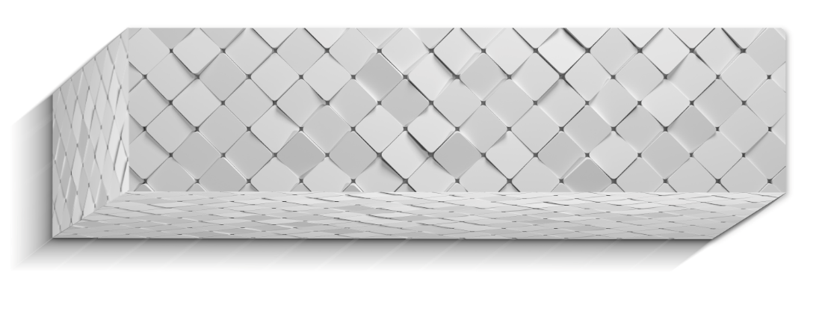

Figure A Barrier