Blood
The sun is falling, and with the lengthening shadows comes a sense of dread. Atavistic men, desperate and degenerate, hunker behind splintered doors and hastily shuttered windows as the few noble souls among them strive to rouse spirits and defenses alike. Howling wolves who walk like men circle the perimeter of the village in hungry packs and large bats cluster like bloated fruits in the eaves of houses, strangely avoiding the belfry of the local church, they all way for the darkness to finally come. For with the midnight hour, that evil which lurks in the dark will come forth, and there will be blood.
Blood is a highly cinematic rule set specifically designed to simulate classic horror films. All games are scenario led and designed to re-create the experience of classic Universal Studios or Hammer Film Productions horrors. Players will not be able to access the full range of their abilities immediately, no self-respecting vampire would kill off the star in the first few minutes, no dramatically driven wolf pack would attack until the tension was truly unbearable and no Van Helsing with any sense of timing would drive the stake home until the final reel. Rather they will need to build up enough Blood points to trigger the abilities needed to secure final victory.
Scenarios are asymmetrical, often highly and possibly unfairly so at first glance. Horror films are rarely, if ever, balanced and fair engagements, far from it. To underline the appropriate sense of tension one side will generally be on the back foot, struggling against the odds and hoping for the sun to rise and end their torment.

First Principles:
- All “Dice” are assumed to be standard D6.
- Any distances may be measured at any time.
Success is Everything:
Whenever a player’s roll is said to result in a “Success” they may elect not to have any direct result of the roll occur. Success will never result in effects the successful player does not want.

Blood Will Out:
If ever a situation or rule interpretation is unclear, the result that produces the most blood points is the correct one.

Gameplay:

Round Structure:
Each Round Consists of the following phases, which should occur in order -
Clean Up
First Blood
Movement
Combat
Bleed Out
During each phase players alternate selecting and activating one model at a time until all models have been activated, such that all models will have moved before any combats, for example.
Clean Up:
All “Temporary” effects end.
First Blood:
Any “Start of turn” Blood Powers may be used and resolved.
Movement:
Models may pivot freely during movement, they may move once per turn in one of four ways -
Hunker – Remain stationary, gain Temporary +2 to all dice rolls.
Cautious – Move up to 3”, gain Temporary +1 to all dice rolls.
Normal – Move up to 6”.
Running – Move up to 9”, suffer Temporary -1 to all dice rolls.
Models may move freely through open space, other models and their bases block movement and may not be overlapped unless otherwise noted. Models in base contact with an enemy model forgo their movement phase entirely.
Combat:
Models may attack any other models in base contact with them. Each model has a number of “Swings” on their profile. They may assign up to one of these swings to any number of models eligible for attacks. After resolving assigned swings any remaining swings may then be assigned and resolved, but swings in second or later rounds may only be assigned to targets that had swings assigned to them in the previous round.
1 – Assign Swings.
2 – Resolve Swings.
3 – Assign any remaining Swings to models that had Swings assigned to them in a previous step.
4 – Return to 2.
To resolve a swing each player should roll a D6 and add their model’s talent along with any other modifiers. The player with the higher score is successful. Any Successful model may then move the shortest possible distance to be in base-to-base contact with no enemies, this movement ignores other models and their bases. A Successful model which initiated the combat may instead elect to cause damage. If causing damage is chosen, each player rolls a D6 and adds the model’s Bulk and any other modifiers. The player with the higher score is successful. A Successful model may have no more Swings assigned to it by the failing model this turn. A Successful model that initiated the attack may reduce the failing model’s Bleed score by one for each point they won by. A model with a Bleed score of zero dies and is removed from the game.
Bleed Out:
Any “End of Turn” Blood Powers may be used during this phase and resolved. Any exchange of blood points between models takes place.
Terrain:
Terrain consists of Hard, Soft and Blocking.
Hard – Models touching Hard terrain gain +1 to all dice rolls during other model’s activations.
Soft – Models within Soft terrain reduce all movement distances and rolls by 1.
Blocking – No model’s move may cause its base to overlap blocking terrain at any point.

The Children of the night
Force Selection:
Basic games should be played to 100 points, all models have the following statistics –
Swings Talent Bulk Bleed Spirit Cost
1 3 3 1 3 5
To add a model to your force, pay the base cost, then select a type under your force entry’s troops and pay any additional cost, finally select any Powers, pay their cost and add them to the model’s profile.
Blood points and powers:
Each force has a range of blood powers unique to them powered by blood points which they earn by a range of actions. These powers and how blood points are earnt define a force’s style and strategy. To use a blood power a model activates it at the time stated and pays its Spend in blood points available to that model.
Hierarchy:
Each force has two hierarchies, one defining how they are selected, one how individuals earn and exchange their blood points.

Humans
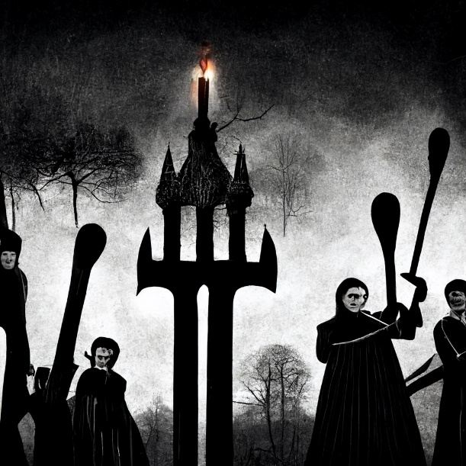
Victims and heroes, the relatively good guys and the slack jawed villagers. Human powers allow the right human to do almost anything but without blood points they are little more than prey. Whilst humans have heroes the true hero is whichever human is the last to die. Tactically humans need to stock up blood points for the last few heroes, trying to save everyone will just kill everyone.
Selection Hierarchy:
Humans may select troops and abilities freely, but note that they come in types either largely generic or totally unique. A group of humans is known as a “Village”.
Blood Hierarchy:
Whenever a friendly human loses a point of bleed they drop an equal number of blood points into a general pool for their group. All human models may access that blood pool freely at any time.
Powers:
Divine Intervention Cost +0 Spend 1
Select a roll where a human model failed it may choose to ignore any effects of the roll. Other models will still be affected. Use at any time.
Panicked Scatter Cost +0 Spend 1
When an enemy model moves to contact with a human all other humans within 6” may be moved up to 6” directly away from the moving enemy model. Humans may not be moved into or our of base contact with an enemy by this move. Use only during the movement phase.
Troops:
Villager
Cost +0
Brute
Bulk +1; Bleed +1; Cost +3
Lamb
Bulk -1; Talent -1; Cost -2
Van Helsing (Unique)
Swing +1; Talent +1; Bleed +2; Spirit +2; Cost +20
Powers:
Improvised Religious Artefact Spend-2
Van Helsing and each enemy in base contact rolls a D6, and adds their Spirit. Any Vampire who fails is moved up to 3” in the direction of the human player’s choice. Use only during the movement phase.
Stake to the Heart Spend-2
Trigger before rolling to cause damage, if successful remove all of the target’s Bleed points. Use only during the combat phase.
Jonathan Harker (Unique)
Swing +2; Bulk +1; Bleed +1; Cost +10
Powers:
Desperate Love Spend-1
All rolls against opponents in base contact with “Mina Harker” gain +1, Temporary. Use at start of turn.
He is Mine Spend-2
All rolls by “Brides” targeting Jonathan Harker suffer a Temporary -3, all rolls by “Fathers” targeting Jonathan Harker gain a Temporary +1.
Mina Harker (Unique)
Bulk -1; Bleed +1; Spirit +3; +10 Cost
Powers:
Not lost Spend-2
Should “Mina Harker” die this turn if a “Bride” dies after her “Mina Harker” replaces the bride, returning with a Bleed of 1. Use at start of turn.
The Woodsman (Unique)
Swing +2; Bulk +2; Bleed +2; Cost +20
Powers:
Silver Edge Spend-2
No model may regain lost bleed this turn. Use at start of turn.
Red Hood (Unique)
Bulk -1; Bleed +1; Sprit +2; Cost +20
Powers:
What big eyes Spend-1
Red Hood and each Alpha rolls a D6, and adds their Spirit. Any Alpha who fails may not attack this turn. Use during the Movement Phase.
What Big Teeth Spend-1
No model may assign more than one swing to Red Hood this turn. Use at Start of turn.
Red Hood Spend-2
Red Hood and target werewolf roll D6 and add their Spirit, if Red Hood Succeeds move the Werewolf up to 9” directly towards Red Hood.

Vampires
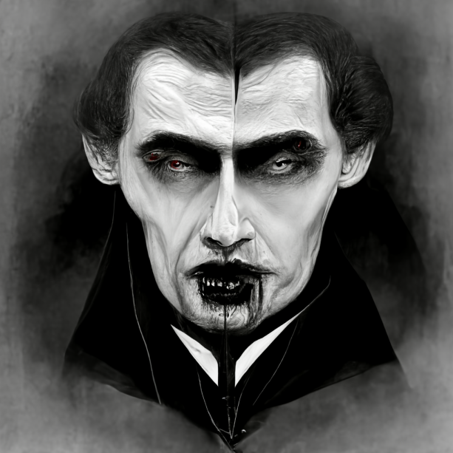
Arrogant, cruel and powerful, the aristocratic society of vampires is ruled by a strict social hierarchy and while individuals can be immensely powerful they lack in trust or inter-reliance such that their arrogance and isolationism makes them fragile.
Selection Hierarchy:
A vampire force may never have more than one “Father”, for each “Father” it may have one “Bride”, for each “Bride” it may have up to two “Thralls”, it may have any number of “Minions”. A group of vampires is known as a “Brood”
Blood Hierarchy:
Any model within a Brood will claim a blood point whenever they cause an opponent’s model to lose a point of Bleed, each Vampire model can only spend their own Blood points. No vampire may target with swings or damaging powers a model that has access to fewer blood points than they have. During Bleed Out Minions may pass Blood Points to Thralls within 3”, Thralls may pass to Brides and Brides to Fathers. At the end of Bleed Out the total Blood points carried by Minions may never be greater than that carried by Thralls, which may never be greater than that carried by Brides, which may never be greater than that carried by Fathers, any excess is lost.
Powers:
Inhuman Strength Cost +5 Spend 0
Bulk +1, Permanent. Killing Power. Use once during set-up.
Inhuman Skill Cost +5 Spend 0
Talent +1, Permanent. Killing Power. Use once during set-up.
Inhuman Speed Cost +5 Spend 0
Swings +1, Permanent. Killing Power. Use once during set-up.
Fatal Strike Cost +10 Spend 2
When this model causes another model to lose a Bleed point, it loses all remaining Bleed points, this model only generates a single Blood point from the attack. Killing Power. Use during Combat phase.
Jugular Bite Cost +5 Spend 1
Before rolling for damage, if successful generate an additional two Blood Points. Killing Power. Use during Combat phase.
Powerful Blow Cost +5 Spend 1
Before rolling for damage, if successful cause an additional point of Bleed. Killing Power. Use during Combat phase.
Bat Form Cost +5 Spend 1
Temporary, move 12”when moving Cautiously. Movement Power. Use during movement phase.
Mist Form Cost +5 Spend 1
Temporary, ignore Terrain, bases and models during movement, ignored by Brood during movement. Movement Power. Use during movement phase.
Mesmeric Stare Cost +10 Spend 2
Select target, this model and target roll a D6 and add spirit. If the target fails they suffer Temporary -1 to all dice and Temporary reduce all movement distances to 0”. Use at start of turn.
Music of the Night Cost +10 Spend 2
Select any number of targets within 12”, this model and any targets roll a D6 and add spirit. If this model succeeds any models that fail have their movement this turn controlled by this model’s controller. Use at start of turn.
Dark Beauty Cost +5
This Force may take +1 Thrall.
Dark Charm Cost +10
This Force may take +1 Bride.
Troops:
Minion
Cost +0; May not take powers.
Thrall
Bleed +1; Cost +0; May only take Killing powers.
Bride
Talent +1; Bulk +1; Spirit +1; Swing +1, Bleed +1; Cost +20; May only take Killing or Movement powers.
Father
Talent +2; Bulk +2; Spirit +2; Swing +2, Bleed +2; Cost +30
Mina Harker, Bride (Unique)
Talent +1; Bulk +1; Spirit +1; Swing +1, Bleed +1; Cost +15
Not Lost
If a Human force “Mina Harker” is present remove this model, if a Human “Mina Harker” is removed, this model replaces it, with full Bleed, if this model is present a Human “Mina Harker” may not replace any other Bride when removed.
Lost
Does not count against the Brood’s limit of Brides.
Dracula, Father (Unique)
Talent +2; Bulk +2; Spirit +2; Swing +2, Bleed +2; Cost +40
Brides of Dracula
This Brood may have +2 Brides.
Master of Darkness
Any powers purchased by this model have their cost reduced by 2.
Ashes and Dust
If this model loses all of its Bleed at the start of each following turn target a single opposing model, roll a D6, add Dracula’s Spirit, the target rolls a D6 and adds its Spirit, if the target fails remove it and replace it with this model with Bleed 1.

Werewolves
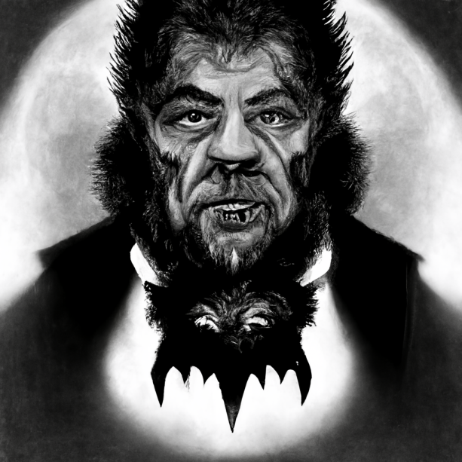
They run as a pack and operate by virtue of mutual support, pulled out of position and isolated they quickly turn from predator to prey. A cursed being the werewolf is always trapped by the very power that offers them liberation.
Selection Hierarchy:
Must have at least two “Omegas” for each “Beta”, must have at least two “Betas” for each “Alpha”. A force of Werewolves is known as a “Pack”.
Blood Hierarchy:
Whenever a model in a Pack causes an opponent to lose a Bleed point up to two models in the same Pack (including the model doing the damage) within 2” of the damaged model may gain a single blood point. Models may only use their own Blood Points. Betas may take Blood Points from Omegas within 2” during Bleed Out, Alphas may take Blood Points from Betas or Omegas with 4” during Bleed Out.
Troops:
Omega
Cost +0
Moonrise Spend 4
Permanently add Talent +1; Bulk +1; Spirit +1; Swing +1, Bleed +1. Use once per game at any point.
Beta
Cost +5
Moonrise Spend 4
Permanently add Talent +1; Bulk +1; Spirit +1; Swing +1, Bleed +1. Use up to twice per game at any point.
Alpha
Talent +1; Bulk +1; Spirit +1; Swing +1, Bleed +1; Cost +25
Moonrise Spend 4
Permanently add Talent +1; Bulk +1; Spirit +1; Swing +1, Bleed +1. Use up to three times per game at any point.
Curse of the revenant Spend 2
Gain 1 Bleed point lost this game.

Scenarios
Once forces are selected a scenario must be chosen, scenarios are of three types:
Horror – Horror scenarios are designed to have balanced rules but to create a sense of pressure and tension for the defending player.
Story – Story scenarios are intended to have asymmetrical conditions in order to create unusual challenges and a general narrative.
Battle – Battle scenarios have more traditional balanced oppositional conditions, themed to the forces in play.
To select a scenario either choose defender and attacker and the type of scenario players would prefer, or roll a D6 and select based on the two forces in play:
Human VS Werewolf
1 – Bar the Doors (Human Defender, Horror)
2 – The Cure (Human Defender, Story)
3 – Village Assault (Human Defender, Battle)
4 – Pull of the Moon (Werewolf Defender, Horror)
5 – Hunt the Hunter (Werewolf Defender, Story)
6 – Trophy Hunt (Werewolf Defender, Battle)
Human VS Vampire
1 – In Plain Sight (Human Defender, Horror)
2 – New Bride (Human Defender, Story)
3 – Assassins (Human Defender, Battle)
4 – Sunrise (Vampire Defender, Horror)
5 – Mirror Ball (Vampire Defender, Story)
6 – Castle Assault (Vampire Defender, Battle)
Vampire VS Werewolf
1 – Pack Blood (Vampire Defender, Horror)
2 – Rise of the Lycans (Vampire Defender, Story)
3 – Forest Ambush (Vampire Defender, Battle)
4 – Moon Phases (Werewolf Defender, Horror)
5 – Rightful Place (Werewolf Defender, Story)
6 – The Challenge (Werewolf Defender, Battle)
Each scenario has four sections:
Set-Up: Details the placement of models and terrain at the beginning of the Scenario, they are played on a 3’ by 3’ area.
Special Rules: Extra or unusual rules.
Win/Loss Conditions: How the defender and attacker win or lose.
Game Length: Set – A preset number of turns; Sunrise – Roll a D6 during Bleed Out, on a 4+ add one to the Sunrise count, the game ends immediately if the count reaches 3; Conditional – The game ends as soon as a stated condition is fulfilled.

Bar the Doors
Defender – Human Attacker – Werewolf Horror
Set-Up: At least one third as many buildings as there are human models and up to half as many should be placed on the table. Each building should be agreed to have at least one door and two windows. All Humans are set up in buildings, all Werewolves touching the same table edge.
Special Rules:
Fear the Night: No human may leave their building.
Barricades: Doors and Windows begin the game as blocking terrain.
Knock Knock: During Movement, before or after moving, once per turn a Werewolf model may force a human within 6” and within 2” of a door or window to roll a D6, if they score over their Spirit the door or window is no longer blocking.
Crash: Werewolves may attack doors which have Bleed 1 and Bulk 3, but do not provide Blood Points. If a door is removed the attacking model may move 2” and gains Temporary +1 Swing.
Reaching in: Models touching a window that is not Blocking is considered in base contact with an model within 1” of the window.
Latch Key: A model within a building may attack a door or window in which case it has a Bleed 1 and Bulk 0.
Win/Loss Conditions: If any Human survive when the game ends, they win.
Game Length: Sunrise.

the cure
Defender – Human Attacker – Werewolf Story
Set-Up: Place at least six pieces of terrain spaced evenly around the table. The Human player places the “Infected” (See Below), then places all their models within 6” of it. The Werewolf player then places all their models anywhere further than 9” from a human.
Special Rules:
The Cure: Number six pieces of Terrain from 1-6, the Werewolf player secretly selects two of them. Whenever a Werewolf dies the Werewolf player must reveal a piece of terrain that was not selected, if there are any. If any Human models direct a total of three swings at a piece of terrain it must be revealed as selected or not. If a piece of terrain is revealed as selected a Human may direct a swing at it to pick up a “dose”. These swings do not need to roll for an attack to be successful.
The Infected: A Human model selected by the Human player is the infected. No Werewolf may attack the infected, the infected may only move cautiously or hunker down, at the start of each phase they roll a D6, on a 4+ they may do nothing for that phase.
Win/Loss Conditions: If a model or models carrying doses from two different pieces of Terrain move into base contact with the infected at the same time the Human win. During Bleed Out roll a D6, if it is higher than the Infected’s Bulk, add one to the Infection Count, if it reaches 3, the Werewolves win.
Game Length: Conditional.

Village Assault
Defender – Human Attacker – Werewolf Battle
Set-Up: Designate an area 1’ by 1’ in the centre of the table, delinate it with walls with a single 4” break in them at one point. Place Soft terrain outside the walls and buildings within. The human player may place up to four 2” by 2” defensive areas on the walls. The Human player deploys all their models first, the Werewolf player deploys anywhere with is models touching table edges. Place an Entrance Barrier across the 4” break in the walls.
Special Rules:
Defensive Areas: Models in Defensive areas may attack targets within 6” rather than base contact.
Entrance Barrier: A model may attack the Entrance Barrier if there are no opposing models touching it, it has Bleed 1 and Bulk Zero.
Walls: A model may move from one side of a Wall to the other for 4” of movement.
Siege: Models are considered to be in base contact with any model touching a Wall or Barrier within 1” of where they are touching it. Models may attack across a Wall or Barrier at -1 to all rolls.
Win/Loss Conditions: During Bleed Out each Werewolf within the central area scores a point. If the Werewolves score 10 points they win.
Game Length: Set 5 Turns.

In Plain Sight
Defender – Human Attacker – Vampires Horror
Set-Up: Humans deploy within 6” of a table edge, the Vampires within 6” of the opposite table edge, the Vampire does not deploy Thralls.
Special Rules:
Trust No One: The Vampire player secretly notes as many non-Unique Human models as they have Thralls. Human models may attack other Human models. If a noted Human model loses a Bleed point remove it and replace it with a Thrall, the Vampire player may replace a noted human with a Thrall at any time.
Win/Loss Conditions: If during Bleed Out there are no Undeployed Thralls and Human models remain, the Humans win. If there are no humans or the game ends, the Vampires win.
Game Length: Set 5 turns.

New Bride
Defender – Human Attacker – Vampires Story
Set-Up: Humans deploy within 6” of a table edge, the Vampires within 6” of the opposite table edge.
Special Rules:
The Bride: The Vampire player secretly selects a Human model, if Mina Harker is present, she must be chosen, the chosen model is “The New Bride”. If the Bride is removed note which model caused their last Bleed point to be removed
Jealous Eyes: If there are Brides on the table, the New Bride may not be attacked by the Vampire Father, the Vampire Father may attack their own Brides. Vampire models in base contact with the New Bride must assign all Swings to it.
Win/Loss Conditions: When the game ends if the New Bride is not in play and the Vampire Father removed its last Bleed point, the Vampires win, if not then the Human player wins.
Game Length: Set 4 turns.

Assassins
Defender – Human Attacker – Vampires Battle
Set-Up: Humans deploy within 12” of the middle of the table, the Vampires touching a single table edge of their choice.
Special Rules:
Alderman: The Human player selects one model to be the “Mayor” it gains +1 Bleed.
Win/Loss Conditions: If the Mayor, the fifth human or the last Vampire dies, the game ends immediately. If the Mayor is dead the Vampires win, if not the Humans win.
Game Length: Conditional.

Pull of the Moon
Defender – Werewolf Attacker – Human Horror
Set-Up: Humans deploy within 6” of a table edge, the Werewolves within 6” of the opposite table edge.
Special Rules:
Silver Moon: At the end of each Movement phase the human player may move up to D6 Werewolf models up to 6” directly towards a Human model of their choice.
Win/Loss Conditions: When the game ends the force with the most models wins.
Game Length: Set 6 turns.

Hunt the hunter
Defender – Werewolf Attacker – Human Story
Set-Up: The human player places up to five “Snare” counters, then the Werewolf deploys their models wherever they wish, then the Human deploys their models wherever they wish.
Special Rules:
Snares: Once each Movement phase the Human player may select a Snare counter and a Werewolf within 12”, they may place the Werewolf on the counter.
Win/Loss Conditions: When a force is wiped out, the game end and that force loses.
Game Length: Conditional.

Trophy hunter
Defender – Werewolf Attacker – Human Battle
Set-Up: Players take turns deploying models wherever they wish at least 6” from an enemy model.
Win/Loss Conditions: When a Werewolf dies the Human model that killed it gains 3 Trophies for an Alpha, 2 for a Beta or 1 for an Omega, a model loses all trophies if slain. The Human can choose to end the game during any Bleed Out phase before the last turn, if the Humans have more Trophies than the current turn number they win.
Game Length: Set 6 turns.

Moon Phases
Defender – Werewolf Attacker – Vampire Horror
Set-Up: The Vampire player deploys their Father wherever they wish, the Werewolf deploys their Alpha wherever they wish, at least 12” from an enemy. Players alternate placing models within 6” of a friendly model and at least 12” from an enemy.
Special Rules:
Moon Shadow: There is a Moon Phase count, it starts on “New Moon”. Each time any model spends a Blood Point roll a D6, on a 4+ move the Moon Phase count on one from “New Moon” to “Crescent Moon” to “Full Moon” then back down again.
During “New Moon” only Alphas may spend Blood Points; During “Crescent Moon” only Alphas and Betas may spend Blood Points. Vampires may spend Blood Points as usual.
Win/Loss Conditions: If the game ends during Full Moon or the Werewolf player has used all “per game” abilities to their limit the Werewolf wins, if not the Vampire wins.
Game Length: Sunrise.

Rightful Place
Defender – Werewolf Attacker – Vampire Story
Set-Up: The Vampire player deploys a piece of terrain; the Werewolf player sets up within 12” of it. The Werewolf player selects a table edge, the Vampire sets up within 12” of it.
Special Rules:
Touch of the Master: If a Vampire would cause damage that would remove a Werewolf they may instead capture it, attacks that result in a Capture do not gain any Blood Points but gain a Capture point. A Father may capture any Werewolf, Brides may not capture Alphas, Thralls may not capture Alphas or Betas, Minions may not capture.
Win/Loss Conditions: If when the game ends if more capture points have been earned than Vampires were removed, the Vampire player wins, if not they lose.
Game Length: Set 6 turns.

Challenge
Defender – Werewolf Attacker – Vampire Battle
Set-Up: The Werewolf player deploys an Alpha anywhere on the table, this is the “Pack Leader”. The Vampire player deploys their Father at least 18” from the Alpha. Players then take turns deploying models within 6” of a friendly model at least 12” from an enemy.
Special Rules:
Mine: The Pack Leader and Vampire Father may only have their last Bleed taken by the other.
Win/Loss Conditions: The game ends when the Pack Leader or Vampire Father are removed, the other side wins.
Game Length: Conditional.

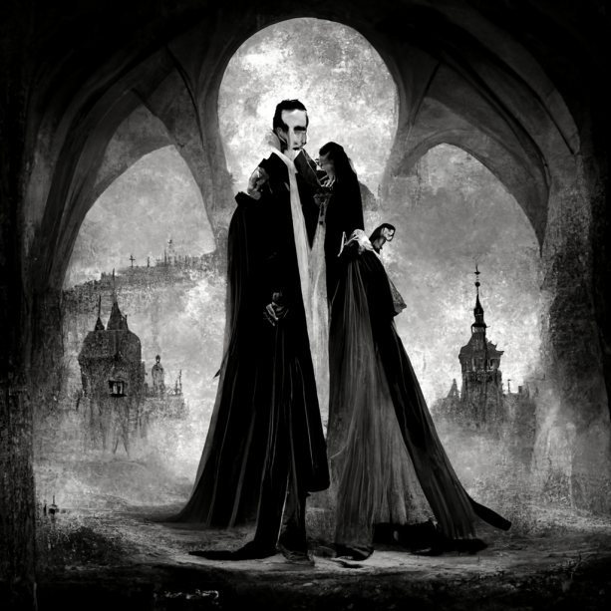
Pack Blood
Defender – Vampire Attacker – Werewolf Horror
Set-Up: The Werewolf deploys wherever they wish, then the Vampire deploys within 12” of a single table edge of their choice.
Special Rules:
Blood Moon: When a Vampire would use a Blood Point roll a D6 first
1: Gain a Blood Point, this model may not use any more Blood Points this turn.
2: Use the Blood Point as usual.
3-4: The Blood Point is not used, this model may not use any more Blood Points this turn.
5: The Werewolf player chooses the target for the ability, including Vampire models.
6: The Blood Point is used, but nothing happens.
Win/Loss Conditions: The Force with the most models remaining wins.
Game Length: Set 6 Turns.

Rise of the Lycans
Defender – Vampire Attacker – Werewolf Story
Set-Up: The Vampire player deploys all models as they choose, then the Werewolf player exchanges the position of any four models with any other four.
Special Rules:
To Freedom: Any Werewolf within 3” of a table edge may be removed by the Werewolf player in the Movement phase or Bleed Out phase.
Win/Loss Conditions: The game ends when the last Werewolf model is removed. If more are removed by the Werewolf player than the Vampire player the Werewolves win, if not they lose.
Game Length: Conditional.

Forest ambush
Defender – Vampire Attacker – Werewolf Battle
Set-Up: The Vampire player deploys at least three soft terrain woods then deploys each of their models wherever they choose at least 6” from a friendly model. Then the Werewolf player deploys all of their models at least 3” from an enemy model.
Special Rules:
Moonlit Woods: Vampires that move into or through woods suffer Temporary -1 to all rolls, Werewolves that move into or through woods gain Temporary +1 to all rolls.
Win/Loss Conditions: The Force with the most models remaining wins.
Game Length: Set 6 Turns.

Sunrise
Defender – Vampire Attacker – Human Horror
Set-Up: Humans deploy within 6” of a table edge, the Vampires within 6” of the opposite table edge.
Special Rules:
The Sun Comes: At the start of each turn the Human player sets a stop watch that runs whenever the Vampire player is active, if it reaches 5 minutes the Vampire player forfeits all remaining actions.
Win/Loss Conditions: The Force with the most models remaining wins.
Game Length: Sunrise.

Mirror Ball
Defender – Vampire Attacker – Human Story
Set-Up: The Human player deploys two 9” long Mirrors touching table edges wherever they wish. Players deploy models one at a time wherever they wish.
Special Rules:
Remain Civil: No model may cause another to lose Bleed points, models may move out of base contact with enemies freely.
In the Mirror: During Combat rather than swinging a Human model may remove a single Vampire model between them and a Mirror, drawing a straight line.
Dark corners: During Combat instead of Swinging a Vampire model may remove a Human model in base contact with two Vampires.
Win/Loss Conditions: The Force with the most models remaining wins.
Game Length: Set 6 Turns.

Castle Assault
Defender – Vampire Attacker – Human Battle
Set-Up: Delineate a 6” square area in the centre of the table, a 12” square around that, and an 18” square around that. Deploy the Father in the centre square, Brides in the next, Thralls in the next and Minions outside. Humans deploy touching a table edge of their choice. Specify a 2” “Door” in the Delineating lines, the lines are blocking, doors are free to pass.
Special Rules:
Castle Walls: Vampires may not pass from one section to another.
Win/Loss Conditions: The centre section is worth 10 points, the next 5, then 3 and Zero. If fewer Humans have been removed than the score for the innermost empty section the Humans win, if not the Vampires win.
Game Length: Set 6 Turns.

Parking lot
Missions should be race specific and oppositional, each group brings their own set of missions.
Other races: Zombies, 1 Source which defines them, Text, Master or Carrier, the rest are a mob, the source defines the Blood Points.
Mad Scientist, total individuals.
Ghouls, Kill and raise.
Witches,
Serial Killers,

